

**Medical Engineering**

**Project Name: Classification of different hand movements using acquired EMG signals**

**Project Book**

|  |  |  |
| --- | --- | --- |
| **Student Name:** | **Niv Edvi** | **Emma Tordjman** |
| **Supervisor’s Name:** | **Dr. Sara Naftali** | **Prof. Anat Ratnovsky** |
| **Initiator:** | **Dr. Sara Naftali** | **Prof. Anat Ratnovsky** |
| **Approved By:** | **Dr. Sara Naftali** | **Prof. Anat Ratnovsky** |
| **Submission Date:** | **29/08/2024** |  |



Table of Contents

List of Tables and Figures 6

1 Abstract 10

2 Abstract in Hebrew 13

3 Key Terms 15

4 Introduction 16

4.1 Project Definition 16

4.2 Goals, Objectives, and Indicators 17

4.2.1 Goals 17

4.2.2 Indicators 17

4.2.3 Objectives 17

5 Background and Literature Review 19

5.1 Anatomical Background 19

5.1.1 Hand and Wrist Bones 19

5.1.2 Hand Muscles 20

5.2 Electromyography 26

5.3 EMG Signal Processing 27

5.4 EMG Feature Extraction 28

5.5 Dimensionality Reduction Methods 31

5.6 Classification of EMG Signals 32

6 Methods 34

6.1 Data Acquisition 35

6.1.1 Experiment Protocol 37

6.2 Signal Processing 38

6.2.1 Pre-filtering and Segmentation 38

6.2.2 Feature Extraction 40

6.3 Machine learning model 41

6.3.1 Subject-Specific - Classification of hand movements of a subject based on its own data 42

6.3.2 General - Classification of hand movements of all subjects 42

7 Results 43

7.1 Raw Data 43

7.2 Classification Results 49

7.2.1 Subject-Specific Model Results 49

7.2.2 General Model Results 68

8 Discussion 73

8.1 Discussion on the values obtained 73

8.2 Comparison with literature data 78

8.2.1 Subject-Specific Models 78

8.2.2 General Models 79

8.3 Error Assessment and Project Limitations 80

8.4 Suggestions for Future Work 81

9 Conclusions 83

10 References 84

11 Appendices 86

11.1 Work Plan 86

11.2 Application form for conducting a non-medical experiment on humans 87

11.3 Changes summary 88

11.4 Python Codes 88

11.5 Project Poster 90

11.6 Previous Study Article 91

# List of Tables and Figures

Figure ‎3‑1 – Wrist & Hand Skeletal Structure 20

Figure ‎3‑2 – Thumb Muscles Diagram 21

Figure ‎3‑3 – Interossei Muscles 23

Figure ‎3‑4 – Palm of the Hand Muscles 24

Figure ‎4‑1 – Progress Flow Chart 34

Figure ‎4‑2 – BIOPAC System Set-up 35

Figure ‎4‑3 – Arm-Hand Muscles Association 37

Figure ‎4‑4 – Electrodes Placement 37

Figure ‎4‑5 – Hand Movements Diagram 38

Figure ‎4‑6 – Data Segmentation steps: (a) Raw signal, (b) Signal Envelope, (c) Signal active region 39

Figure ‎4‑7 – Spectrogram of a single segment EMG 40

Figure ‎5‑1 – Raw Data Section, Flexion 44

Figure ‎5‑2 – Raw Data Section, Extension 44

Figure ‎5‑3 – Raw Data Section, Ulnar Deviation 45

Figure ‎5‑4 – Raw Data Section, Radial Deviation 45

Figure ‎5‑5 – Raw Data Section, Hook Grip 46

Figure ‎5‑6 – Raw Data Section, Power Grip 46

Figure ‎5‑7 – Raw Data Section, Precision Grip 47

Figure ‎5‑8 – Raw Data Section, Spherical Grip 47

Figure ‎5‑9 – Raw Data Section, Lateral Grip 48

Figure ‎5‑10 – Raw Data Section, Pinch Grip 48

Figure ‎5‑11 – Results for the 4 classifiers, for subject 1 52

Figure ‎5‑12 – Results for the 4 classifiers across 9 movements, for subject 1 52

Figure ‎5‑13 – Results for the 4 classifiers, for subject 2 53

Figure ‎5‑14 – Results for the 4 classifiers across 9 movements, for subject 2 53

Figure ‎5‑15 – Results for the 4 classifiers, for subject 3 54

Figure ‎5‑16 – Results for the 4 classifiers across 9 movements, for subject 3 54

Figure ‎5‑17 – Results for the 4 classifiers, for subject 4 55

Figure ‎5‑18 – Results for the 4 classifiers across 9 movements, for subject 4 55

Figure ‎5‑19 – Results for the 4 classifiers, for subject 5 56

Figure ‎5‑20 – Results for the 4 classifiers across 9 movements, for subject 5 56

Figure ‎5‑21 – Results for the 4 classifiers, for subject 6 57

Figure ‎5‑22 – Results for the 4 classifiers across 9 movements, for subject 6 57

Figure ‎5‑23 – Results for the 4 classifiers, for subject 7 58

Figure ‎5‑24 – Results for the 4 classifiers across 9 movements, for subject 7 58

Figure ‎5‑25 – ROC curve across 9 movements, for subject 1 60

Figure ‎5‑26 – ROC curve across 9 movements, for subject 2 60

Figure ‎5‑27 – ROC curve across 9 movements, for subject 3 61

Figure ‎5‑28 – ROC curve across 9 movements, for subject 4 61

Figure ‎5‑29 – ROC curve across 9 movements, for subject 5 62

Figure ‎5‑30 – ROC curve across 9 movements, for subject 6 62

Figure ‎5‑31 – ROC curve across 9 movements, for subject 7 63

Figure ‎5‑32 – 3 axes LDA scattering for subject 1 65

Figure ‎5‑33 – 3 axes LDA scattering for subject 2 65

Figure ‎5‑34 – 3 axes LDA scattering for subject 3 66

Figure ‎5‑35 – 3 axes LDA scattering for subject 4 66

Figure ‎5‑36 – 3 axes LDA scattering for subject 5 67

Figure ‎5‑37 – 3 axes LDA scattering for subject 6 67

Figure ‎5‑38 – 3 axes LDA scattering for subject 7 68

Figure ‎5‑39 – Results for the 4 classifiers, for all subjects combined 71

Figure ‎5‑40 – Results for the 4 classifiers across 9 movements, for all subjects combined 71

Figure ‎5‑41 – ROC curve across 9 movements, for all subjects combined 72

Figure ‎6‑1 – Classifier average results for single VS all average scores 75

Figure ‎6‑2 – Classifier average results for single VS all average scores per movement (class) 76

Table ‎4‑1 – Subject Information Range 36

Table ‎5‑1 – Summary of average ±SD of the AUC, F1score and Accuracy obtained for each subject by each of the classifiers for multiclassification of different hand movements for the subject-specific model 51

Table ‎5‑2 – Classifiers values and standard deviation (±SD) for each movement for the subject specific model 51

Table ‎5‑3 – Classifiers values and standard deviation (±SD) for the general model 70

Table ‎5‑4 – Classifiers values and standard deviation (±SD) for each movement for the general model 70

Table ‎9‑1 – Work Plan 86

Table ‎9‑2 – Approval of the internal ethics committee of Afeka college of engineering 87

# Abstract

Surface electromyography (EMG) is a non-invasive technique for acquiring signals that reflect the electrical activity produced by muscles. This activity varies not only with the movement, intensity, and workload of the muscles but also with their size; larger muscles typically generate stronger EMG signals due to the greater number of active motor units. This project explores the classification of hand movements using EMG signals, a focus motivated by the hand's intricate array of movements that are essential for a broad spectrum of applications, from advanced prosthetics to user interfaces in interactive entertainment. Understanding the nuanced electrical activity associated with different hand movements can significantly enhance the design and functionality of devices that rely on accurate movement detection and replication.

The motivation behind this work lies in its potential to revolutionize fields that depend on precise hand movement detection and replication, such as rehabilitative medicine, where it can enhance the efficacy of therapy for individuals with hand function impairments, and in the development of more responsive and intuitive prosthetic devices. Furthermore, the project aims to advance the integration of human movements into entertainment technologies, making gaming and virtual reality experiences more immersive and accessible.

Previous studies have primarily focused on using single-muscle recordings and lower sampling rates for the classification of basic hand movements. These studies provided valuable insights but were limited by the reduced complexity of the datasets and the methods employed. They often utilized basic machine learning models and simpler signal processing techniques, achieving varying levels of precision in classifying hand movements. However, the potential for improving classification precision through more sophisticated methods and richer datasets was evident, paving the way for this project.

In this project, **EMG signals were recorded from three different hand muscles, providing a richer dataset compared to single-muscle recordings. This approach enabled us to capture a more comprehensive view of hand movements, encompassing the diverse roles played by each muscle in movement execution.** The dataset includes signals from 10 distinct hand movements, collected from a varied group of subjects characterized by differences in gender, age, weight, dominant hand, and hand size. This diversity ensures the generalizability of the findings across a wide population spectrum.

The primary goal of this project was to improve the classification precision of hand movements using advanced machine learning models. For this purpose, models such as Random Forest (RF), K-Nearest Neighbors (KNN), and Support Vector Machine (SVM) were employed. These models are known for their efficacy in recognizing patterns in spectral and temporal data, which are critical in EMG signal classification. These models discerned the subtle differences in EMG signal patterns corresponding to different hand gestures, offering high precision in movement classification. Additionally, a Voting Classifier was implemented, an ensemble model that combined the predictions of RF, KNN, and SVM to enhance overall precision.

The methods used in this project included the Short-Time Fourier Transform (STFT) for feature extraction, which allowed to capture both time and frequency information from the EMG signals. **To manage the high dimensionality of the extracted features, Linear Discriminant Analysis (LDA) was applied, reducing the feature space while retaining the most relevant information for classification.** The classification process was carried out in two stages: a subject-specific model, where hand movements were classified based on individual subjects’ data, and a general model, which utilized combined data from all subjects.

**The results demonstrated high precision in classifying hand movements. The subject-specific model achieved an overall average precision of 91.9%, while the general model reached 88.3% precision. The Voting Classifier outperformed individual classifiers in both models, highlighting the robustness of the ensemble approach. These findings suggest that the methods developed in this project could significantly enhance technologies reliant on precise hand movement detection.**

**This comprehensive study not only highlights the potential of EMG signals in classifying hand movements but also sets a foundational framework for future innovations in EMG signal application. The results obtained promise significant advancements in medical diagnostics, prosthetic development, and interactive technology. Future work should focus on expanding the dataset, refining segmentation techniques, and exploring real-time applications of these models, further enhancing their efficacy and utility.**

# ****Abstract in Hebrew****

אלקטרומיוגרפיה משטחית (EMG) היא טכניקה לא פולשנית לרכישת אותות המשקפים את הפעילות החשמלית המופקת על ידי השרירים. פעילות זו משתנה לא רק עם התנועה, העוצמה ועומס העבודה של השרירים אלא גם עם גודלם; שרירים גדולים יותר יוצרים בדרך כלל אותות EMG חזקים יותר בגלל המספר הגדול יותר של יחידות מוטוריות פעילות. פרויקט זה בוחן את הסיווג של תנועות ידיים באמצעות אותות EMG, מיקוד המונע על ידי מערך התנועות המורכב של היד החיוניות עבור קשת רחבה של יישומים, החל מתותבות מתקדמות ועד ממשקי משתמש בבידור אינטראקטיבי. הבנת הפעילות החשמלית הניואנסית הקשורה לתנועות ידיים שונות יכולה לשפר משמעותית את העיצוב והפונקציונליות של מכשירים המסתמכים על זיהוי ושכפול תנועה מדויקים.

המניע מאחורי עבודה זו טמון בפוטנציאל שלה לחולל מהפכה בתחומים התלויים בזיהוי ושכפול מדויק של תנועות ידיים, כגון רפואה שיקומית, שבה היא יכולה לשפר את יעילות הטיפול עבור אנשים עם ליקויים בתפקוד הידיים, ובפיתוח של מגיבים יותר מכשירים תותבים אינטואיטיביים. יתר על כן, הפרויקט נועד לקדם את השילוב של תנועות אנושיות בטכנולוגיות בידור, מה שהופך את חוויות המשחקים והמציאות המדומה לסוחפת ונגישה יותר.

מחקרים קודמים התמקדו בעיקר בשימוש בהקלטות של שריר בודד ושיעורי דגימה נמוכים יותר לסיווג תנועות ידיים בסיסיות. מחקרים אלה סיפקו תובנות חשובות אך הוגבלו על ידי המורכבות המופחתת של מערכי הנתונים והשיטות שננקטו. לעתים קרובות הם השתמשו במודלים בסיסיים של למידת מכונה וטכניקות עיבוד אותות פשוטות יותר, והשיגו רמות שונות של דיוק בסיווג תנועות ידיים. עם זאת, הפוטנציאל לשיפור דיוק הסיווג באמצעות שיטות מתוחכמות יותר ומערכי נתונים עשירים יותר היה ברור, מה שסלל את הדרך לפרויקט זה.

בפרויקט זה, אותות EMG תועדו משלושה שרירי יד שונים, מה שמספק מערך נתונים עשיר יותר בהשוואה להקלטות של שריר בודד. גישה זו אפשרה לנו ללכוד תצוגה מקיפה יותר של תנועות ידיים, הכוללת את התפקידים המגוונים שמילא כל שריר בביצוע התנועה. מערך הנתונים כולל אותות מ-10 תנועות ידיים שונות, שנאספו מקבוצה מגוונת של נבדקים המאופיינים בהבדלים במגדר, גיל, משקל, יד דומיננטית וגודל יד. גיוון זה מבטיח את יכולת הכללה של הממצאים על פני קשת אוכלוסייה רחבה.

המטרה העיקרית של פרויקט זה הייתה לשפר את דיוק הסיווג של תנועות ידיים באמצעות מודלים מתקדמים של למידת מכונה. לשם כך, הופעלו מודלים כמו יער אקראי (RF), K-Nearest Neighbors (KNN) וSupport Vector Machine (SVM). מודלים אלו ידועים ביעילותם בזיהוי דפוסים בנתונים ספקטרליים וזמניים, שהם קריטיים בסיווג אותות EMG. מודלים אלה הבחינו בהבדלים העדינים בדפוסי אותות EMG התואמים לתנועות ידיים שונות, ומציעים דיוק גבוה בסיווג התנועה. בנוסף, הופעל מיון הצבעה, מודל אנסמבל ששילב את התחזיות של RF, KNN ו-SVM כדי לשפר את הדיוק הכולל.

השיטות ששימשו בפרויקט זה כללו טרנספורמציה פורייה קצרה (STFT) לחילוץ פיצרים, שאפשרה ללכוד מידע על זמן ותדירות מאותות EMG. כדי לנהל את הממדיות הגבוהה של התכונות שחולצו, הוחל ניתוח מבחן ליניארי (LDA), תוך צמצום מרחב התכונות תוך שמירה על המידע הרלוונטי ביותר לסיווג. תהליך הסיווג בוצע בשני שלבים: מודל ספציפי לנושא, שבו תנועות הידיים סווגו על סמך נתוני הנבדקים הבודדים, ומודל כללי, שהשתמש בנתונים משולבים מכל הנבדקים.

התוצאות הראו דיוק גבוה בסיווג תנועות ידיים. המודל הספציפי לנושא השיג דיוק ממוצע של 91.9%, בעוד המודל הכללי הגיע ל-88.3% דיוק. סיווג ההצבעה עלה על ביצועיו של מסווגים בודדים בשני הדגמים, והדגיש את החוסן של גישת האנסמבל. ממצאים אלו מצביעים על כך שהשיטות שפותחו בפרויקט זה יכולות לשפר באופן משמעותי טכנולוגיות הנשענות על זיהוי מדויק של תנועת ידיים.

מחקר מקיף זה לא רק מדגיש את הפוטנציאל של אותות EMG בסיווג תנועות ידיים אלא גם קובע מסגרת יסוד לחידושים עתידיים ביישום אותות EMG. התוצאות שהתקבלו מבטיחות התקדמות משמעותית באבחון רפואי, פיתוח תותבות וטכנולוגיה אינטראקטיבית. עבודה עתידית צריכה להתמקד בהרחבת מערך הנתונים, חידוד טכניקות פילוח וחקירת יישומים בזמן אמת של מודלים אלה, תוך שיפור היעילות והתועלת שלהם.

# Key Terms

1. **Surface Electromyography (EMG)** - Non-invasive method for recording muscle electrical activity.
2. **Short-Time Fourier Transform (STFT)** - Analyzes signal frequency over time for feature extraction.
3. **Linear Discriminant Analysis (LDA) -** Reduces data dimensionality while maximizing class separability.
4. **Random Forest (RF) -** A machine learning model using multiple decision trees for classification.
5. **K-Nearest Neighbors (KNN) -** A simple algorithm that classifies data based on the closest neighbors.
6. **Support Vector Machine (SVM) -** A machine learning model that finds the optimal boundary between classes.
7. **Voting Classifier -** Ensemble method combining multiple models to improve accuracy.
8. **Feature Extraction -** Process of identifying key characteristics from raw data.
9. **Dimensionality Reduction -** Technique to decrease the number of features while retaining essential information.
10. **Cross-Validation -** Technique to evaluate model performance by splitting data into training and testing sets.

# Introduction

## Project Definition

This project is a continuation of previous research on the topic of the classification of hand movements based on EMG signals and machine learning techniques [1]*.* The objective of the project was to introduce further measurements of EMG signals that were taken simultaneously from 3 different muscles in the frequency of 1000 Hz as opposed to the previous research that collected data from an online source in the frequency of 500 Hz. In addition, the project aimed to use new techniques of data acquisition, signal processing and data classification.

This project dealt with the task of creating models, using Machine Leaning techniques, to automate the identification and classification of different hand movements based on the signals detected in the muscles (EMG). The signals, once acquired, were processed, and analyzed using two different models: a subject-specific model (based on the subject’s own data) and a general model (based on mixed data from all subjects). The signals were then classified using one of the models and identified to match the movement in question.

The significance of this research can be seen in many different fields of application, most notably: medical diagnosis, prosthetics implementation, robotics exoskeletons, entertainment (i.e., video games) and a variety of potential subfields. The results may inspire future research and provide solid ground to improve and develop the applications of the project further.

## Goals, Objectives, and Indicators

### Goals

The main goal of this project is to identify different hand movements based on EMG signals utilizing machine learning models. An algorithm was developed to remove noises, enhance, and refine the signals acquired, and utilize banks of data to properly match the processed signals with the associated hand movements.

### Indicators

There were 3 main indicators that measured the success of the project. The Accuracy of the classification, F1score and AUC (Area Under Curve). In both models, the indication for success was an AUC score of over 80% and an Accuracy score of over 80% as well. Furthermore, another indication for successful data separation is whether the data is clustered in groups by each movement when plotting the data after dimensionality reduction.

### Objectives

The following specific aims were undertaken to achieve the main goal:

* EMG signals were measured from 3 different hand muscles during 10 different hand movements, involving 7 subjects.
* Different processing methods were explored to enhance the quality of the EMG signals, including techniques such as noise filtering and segmenting the signals based on relevant muscle activity.
* An algorithm for pre-processing the EMG signals was developed. This algorithm incorporated noise filtering and manual signal segmentation based on muscle activity to ensure accurate and reliable data for further analysis.
* Algorithms were designed for extracting features, developing machine learning models, and implementing classification techniques.
* Statistical analysis was conducted on the results obtained from the models. This analysis provided insights into the success and efficacy of the classification process, allowing for a better understanding of the model’s performance.

# Background and Literature Review

## Anatomical Background

Numerous muscles, ligaments, tendons, and sheaths can be found within the hand. The muscles are the structures that can contract, allowing movement of the bones in the hand. The ligaments are fibrous tissues that help bind together the joints in the hand. The sheaths are tubular structures that surround part of the fingers. The tendons connect muscles in the arm or hand to the bone to allow movement. In addition, there are arteries, veins and nerves within the hand that provide blood flow and sensation to the hand and fingers.

### Hand and Wrist Bones

The hand is composed of different bones that allow a large amount of movement and dexterity. There are 3 major types of bones in the hand itself: phalanges, metacarpal bones, and carpal bones [1]. The phalanges are 14 bones that are found in the fingers of each hand. Each finger has 3 phalanges (the distal, middle, and proximal) but the thumb only has 2 [2]. The metacarpal bones are 5 bones that compose the middle part of the hand. The carpal bones are 8 bones that create the wrist. The wrist joint is the complex joint that connects the forearm to the hand and is formed between the distal ends (furthest from the body) of the Radius and Ulna (two forearm bones) and the carpal bones. Altogether there are 8 carpal bones which are arranged in two rows, proximal and distal: Lunate, Triquetrum, Pisiform, Capitate, Trapezium, Trapezoid, Hamate and Scaphoid [3].

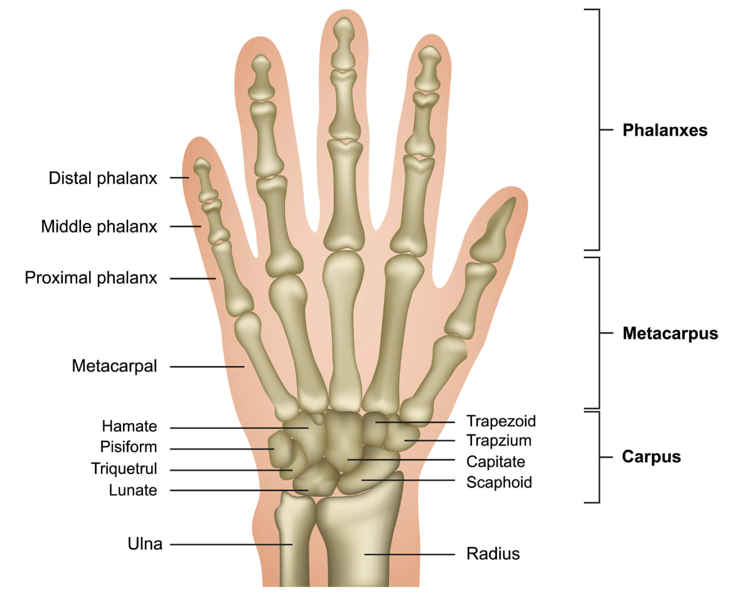

Figure ‎5‑1 – Wrist & Hand Skeletal Structure

### Hand Muscles

Hand muscles are divided into three groups: those of the thumb, which occupy the radial side, those of the other four fingers, which occupy the ulnar side and those in the middle of the palm and between the metacarpal bones.

There are four muscles in the thumb: Abductor Pollicis Brevis, Opponens Pollicis, Flexor Pollicis Brevis and Adductor Pollicis [1]. These muscles are innervated by different nerves. The Abductor Brevis, Opponens, and lateral head of the Flexor Pollicis Brevis are supplied by the sixth and seventh cervical nerves through the median nerve. The medial head of the Flexor Pollicis Brevis and the Adductor are innervated by the eighth cervical nerve through the ulnar nerve.

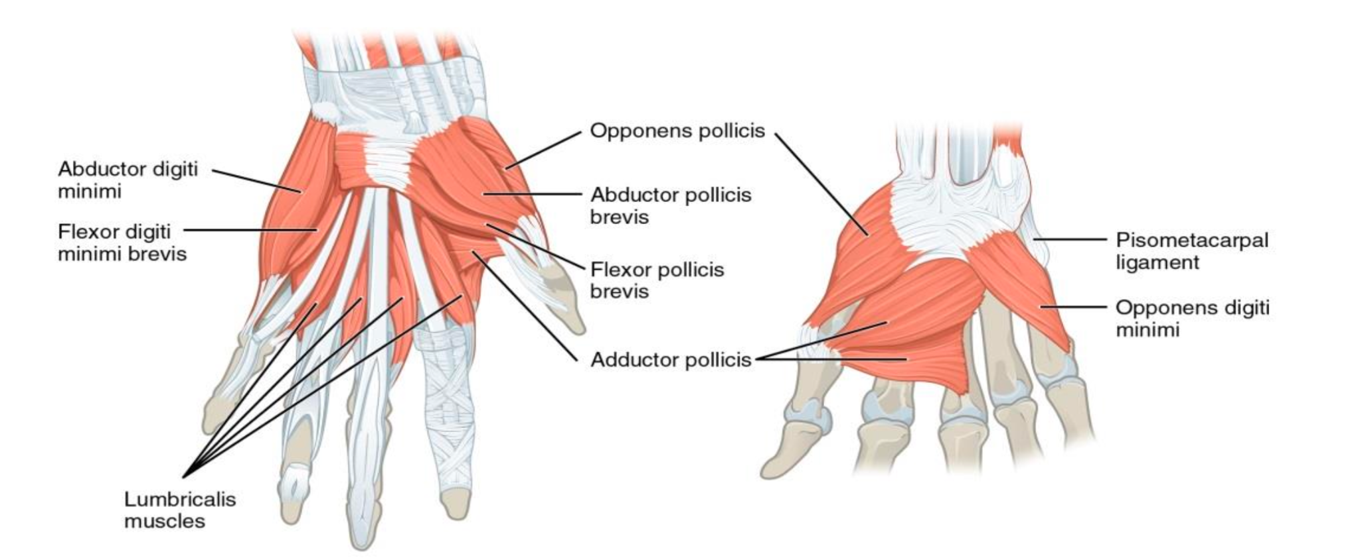

Figure ‎5‑2 – Thumb Muscles Diagram

The Abductor Pollicis brevis is a thin and flat muscle located right beneath the skin. It originates from the transverse carpal ligament, tuberosity of the navicular bone, and the ridge of the greater multangular bone. It inserts into the radial side of the base of the first phalanx of the thumb and the capsule of the metacarpophalangeal joint. Its main function is to draw the thumb away from the palm in a plane perpendicular to the hand.

The Opponens Pollicis is a small, triangular muscle that lies beneath the Abductor Pollicis Brevis. It arises from the ridge on the greater multangular bone and the transverse carpal ligament. It inserts along the radial side of the metacarpal bone of the thumb. Its action is to flex the metacarpal bone of the thumb medially over the palm.

The Flexor Pollicis Brevis consists of two portions: lateral and medial. The lateral portion originates from the transverse carpal ligament and the lower part of the ridge on the greater multangular bone. It inserts into the radial side of the base of the first phalanx of the thumb. The medial portion arises from the ulnar side of the first metacarpal bone and inserts into the ulnar side of the base of the first phalanx. The Flexor Pollicis Brevis flexes and adducts the proximal phalanx of the thumb.

The Adductor Pollicis is made of two parts: the oblique and transverse portions. The oblique part arises from the Capitate bone, bases of the second and third metacarpals, intercarpal ligaments, and the sheath of the flexor carpi radialis tendon. Its fibers converge to form a tendon that inserts into the ulnar side of the base of the first phalanx of the thumb. The transverse part arises from the lower two-thirds of the volar surface of the third metacarpal bone and inserts with the medial part of the Flexor Pollicis Brevis and the oblique part into the ulnar side of the base of the first phalanx. The Adductor Pollicis brings the thumb toward the palm and opposes the action of the Abductor Pollicis Brevis.

The four fingers are called the index finger, the middle finger, the ring finger, and the little finger. They are associated to the lumbricals and interossei muscles [1], [3]. The Lumbricals and interossei muscles are innervated by different nerves. The lateral Lumbricals are supplied by the sixth and seventh cervical nerves through the digital branches of the median nerve, while the medial Lumbricals and all the Interossei muscles are supplied by the eighth cervical nerve through the deep palmar branch of the ulnar nerve. The third lumbricalis often receives a branch from the median nerve.

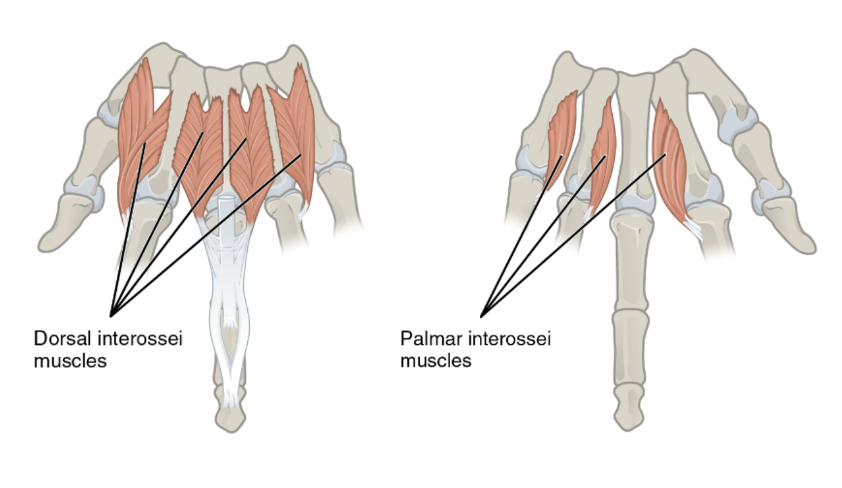

Figure ‎5‑3 – Interossei Muscles

The Lumbricals are four lumbrical muscles, each associated with the tendon of the flexor digitorum profundus of its respective finger. The first and second Lumbricals arise from the tendons of the index and middle fingers, respectively. The third Lumbrical arises from the tendons of the middle and ring fingers, and the fourth Lumbrical arises from the tendons of the ring and little fingers. They pass to the radial side of each finger and insert into the tendinous expansion of the extensor digitorum communis on the dorsal aspect of the finger. The Lumbricals flex the first phalanges at the metacarpophalangeal joints and extend the second and third phalanges through their insertions into the extensor tendons.

The Interossei muscles can be divided into two categories: the dorsal and the palmar Interossei muscles.

There are four Dorsal Interossei muscles located between the metacarpal bones [1]. Each muscle arises from two heads on the adjacent sides of the metacarpal bones and inserts into the bases of the first phalanges and the aponeuroses of the extensor digitorum communis tendons. These muscles contribute to the abduction of the fingers away from an imaginary line drawn through the center of the middle finger. The radial artery passes through one of the triangular intervals between the double origin of each muscle, while the other three intervals transmit perforating branches from the deep volar arch.

There are three Palmar Interossei muscles [1] which are smaller than the Dorsal Interossei. They are located on the volar surfaces of the metacarpal bones. Each muscle arises from the entire length of a metacarpal bone and inserts into the side of the base of the first phalanx and the aponeurotic expansion of the extensor digitorum communis tendon for the same finger. The Palmar Interossei contribute to the adduction of the fingers toward the imaginary line drawn through the center of the middle finger.

There are four muscles in the palm of the hand [1]: Palmaris Brevis, Abductor Digiti Quinti, Flexor Digiti Quinti Brevis and Opponens Digiti Quinti. These muscles are innervated by the eighth cervical nerve through the ulnar nerve.

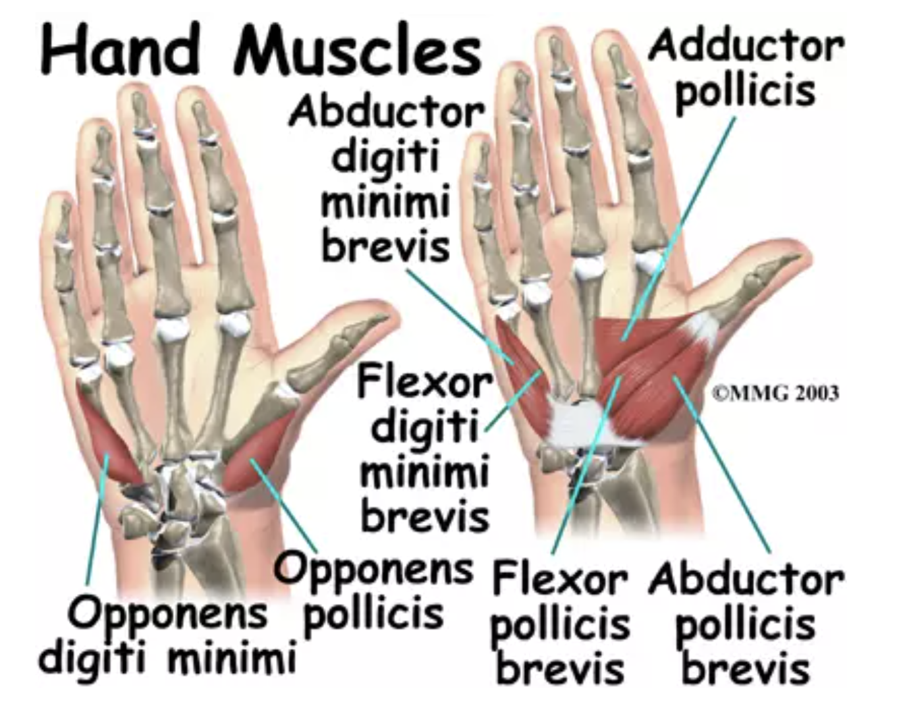

Figure ‎5‑4 – Palm of the Hand Muscles

The Palmaris Brevis is a thin, quadrilateral muscle located beneath the skin on the ulnar side of the hand. It originates from the transverse carpal ligament and palmar aponeurosis, and its fleshy fibers insert into the skin along the ulnar border of the palm. The Palmaris Brevis muscle corrugates the skin on the ulnar side of the palm.

The Abductor Digiti Quinti is situated on the ulnar border of the palm, this muscle arises from the pisiform bone and the tendon of the Flexor Carpi Ulnaris. It ends in a flat tendon that divides into two slips. One slip inserts into the ulnar side of the base of the first phalanx of the little finger, and the other inserts into the ulnar border of the aponeurosis of the Extensor Digiti Quinti Proprius.

The Flexor Digiti Quinti Brevis is positioned on the radial side of the Abductor Digiti Quinti and originates from the convex surface of the hamulus of the hamate bone and the volar surface of the transverse carpal ligament. It inserts into the ulnar side of the base of the first phalanx of the little finger. The Flexor Digiti Quinti Brevis helps in abducting the little finger from the ring finger and assists in flexing the proximal phalanx.

The Opponens Digiti Quinti is a triangular muscle that lies beneath the previous muscles. It arises from the convexity of the hamulus of the hamate bone and the contiguous portion of the transverse carpal ligament. It inserts along the ulnar margin of the metacarpal bone of the little finger. The Opponens Digiti Quinti draws the fifth metacarpal bone forward, deepening the hollow of the palm.

## Electromyography

EMG is a technique used to measure and evaluate the electrical activity generated by skeletal muscles. It involves the detection and recording of action potentials and motor unit activity in muscles [4]. The signals are typically detected using needle electrodes inserted into the muscle tissue, although surface electrodes can also be used. Electromyography provides valuable information about muscle activation, recruitment patterns, and neuromuscular control. It allows for the assessment of muscle function, identification of abnormalities, and diagnosis of various neuromuscular disorders. The recorded electrical signals, known as EMG waveforms (the electromyogram), can be analyzed for amplitude, duration, frequency, and other parameters to gain insights into muscle health and performance [5].

The procedure involves the placement of electrodes into the muscle, which detect the electrical signals produced by motor unit activity during muscle contraction and relaxation. The patient may be asked to perform specific movements or contract the muscles being examined to assess their function and activation patterns. The recorded signals are amplified, filtered, and displayed on a screen, enabling analysis.

EMG is widely used in clinical settings for the evaluation of neuromuscular conditions such as peripheral nerve injuries, myopathies, and motor neuron disorders [6]. It aids in the localization of muscle pathology, assessment of nerve conduction abnormalities, and identification of muscle activation patterns. EMG findings can guide treatment decisions, monitor disease progression, and evaluate the effectiveness of therapeutic interventions.

While EMG is generally considered safe, potential risks include minor discomfort during needle insertion, bruising, and infection. EMG has some limitations, as it provides localized information and cannot assess overall muscle function or detect certain types of muscle disorders. Complementary tests, such as nerve conduction studies and imaging, may be necessary for a comprehensive evaluation [7].

EMG is a valuable tool for assessing muscle electrical activity, diagnosing neuromuscular disorders, and investigating muscle physiology, biomechanics, and motor control and aiding in clinical diagnoses, treatment planning, and scientific research. It provides detailed information about muscle function and activation patterns, muscle coordination, and the mechanisms underlying muscle fatigue and performance.

## EMG Signal Processing

EMG signal processing generally involves several key stages: pre-processing, filtering, and data segmentation [6], [8]. These steps are essential for ensuring the quality and reliability of the EMG signals used for further analysis. Common practices in EMG signal processing include:

* **Pre-Processing:** The raw EMG data is typically prepared by removing noise and artifacts. Techniques such as rectification, normalization, and the application of smoothing filters, like low-pass filters, are often used to improve signal clarity.
* **Filtering:** Filters are applied to isolate specific frequency ranges of interest and remove unwanted noise. Common filters include low-pass, high-pass, and band-pass filters, which help in focusing on the relevant parts of the EMG signal while discarding the rest.
* **Data Segmentation:** Data segmentation involves dividing the continuous EMG signal into segments corresponding to specific hand movements. This step is critical for associating specific muscle activity with each movement.

In this project, specific techniques were employed, particularly in data segmentation, which was crucial for the accurate classification of hand movements. For this study, manual data segmentation was chosen over automated methods. This decision was made after it was observed that automated segmentation did not consistently capture the start and end points of each movement with sufficient accuracy, leading to potential errors in the analysis.

## EMG Feature Extraction

EMG feature extraction refers to the process of analyzing electromyogram signals to extract meaningful features or characteristics that can provide valuable information about muscle activity and function [9]. Feature extraction involves translating these raw signals into meaningful data that can be used for various applications, including clinical diagnosis, rehabilitation, human-machine interface development, and sports science. The goal is to identify characteristics of the EMG signal that are relevant to the task at hand, such as detecting muscle fatigue, evaluating muscle performance, or controlling prosthetic devices. These features are used for various purposes such as pattern recognition, classification, and interpretation of EMG signals. There are Time-Domain Features, Frequency-Domain Features, Time-Frequency Features and Nonlinear Features.

Frequency-Domain features analyze the frequency content of the EMG signal, often used to study muscle fatigue. Frequency-domain features involve analyzing the spectral content of the EMG signal by performing techniques such as Fourier transform [4]. Median Frequency represents the frequency at which half of the EMG power is below and half is above. It is indicative of muscle fatigue and changes in muscle fiber recruitment patterns. Power Spectral Density describes the distribution of power in the frequency spectrum of the EMG signal. Different frequency bands can be analyzed to extract specific frequency-related information.

The Short-Time Fourier Transform (STFT) is a mathematical tool used to analyze the frequency content of a signal as it varies over time. It is particularly useful for non-stationary signals, where the frequency components change over time, such as EMG signals during muscle activity. The STFT works by dividing the signal into smaller segments, or windows, and then applying the Fourier Transform to each window, resulting in a time-frequency representation of the signal. This allows for the observation of how the frequency content of the signal evolves over time.

In this project, the STFT was chosen due to its ability to capture both time and frequency information, making it well-suited for analyzing the dynamic nature of EMG signals during hand movements. The STFT was applied to each segmented portion of the EMG data using a window size of 256 samples with an overlap of 128 samples. This approach provided a detailed matrix of frequency distributions for each segment, which was then used to extract relevant features for further classification tasks. The use of STFT enabled a more nuanced analysis of the EMG signals, contributing to the accuracy and effectiveness of the movement classification models.

The selection of specific feature extraction techniques depends on the research or clinical objectives, the characteristics of the EMG signals, and the specific application or analysis being performed. These extracted features are often used as inputs for machine learning algorithms or statistical analysis to classify muscle activities, detect abnormalities, monitor muscle performance, or develop control strategies for prosthetic devices or rehabilitation purposes [5], [6].

Applications of EMG Feature Extraction:

* Clinical Diagnostics - helps in diagnosing neuromuscular diseases and assessing rehabilitation progress.
* Prosthetic Control - features extracted from EMG signals are used to control artificial limbs, allowing for natural-like movements based on the user's muscle activity.
* Human-Machine Interfaces - EMG signals can control external devices, providing a means for humans to interact with computers and other machines directly through muscle activity.

The quality of EMG signals can be affected by various factors, including electrode placement, skin preparation, and external noise. Ensuring high-quality signals is crucial for reliable feature extraction. There is significant variability in EMG signals between individuals and even for the same individual under different conditions. Tailoring feature extraction and analysis to individual characteristics can enhance application effectiveness. Some feature extraction methods, especially in the time-frequency domain, can be computationally intensive. Balancing the detail and complexity of feature extraction with computational efficiency is important for real-time applications. EMG feature extraction is a field of ongoing research, with advances in signal processing techniques and machine learning algorithms continually improving the ability to analyze and interpret EMG signals for a wide range of applications.

## Dimensionality Reduction Methods

Dimensionality reduction methods are techniques used to reduce the number of features or variables in a dataset while preserving as much relevant information as possible. These methods are commonly employed in data preprocessing and analysis to address the challenges and issues of working with high-dimensional data and improve computational efficiency. Common dimensionality reduction methods include: Principal Component Analysis (PCA), Linear Discriminant Analysis (LDA) and Independent Component Analysis (ICA) [10].

The choice of dimensionality reduction method depends on the specific characteristics of the data, the desired level of reduction, and the objectives of the analysis or task at hand. It is important to assess the impact of dimensionality reduction on the overall performance of the subsequent analysis or model.

Linear Discriminant Analysis (LDA) is a dimensionality reduction method that aims to find a lower-dimensional representation of the data that maximizes class separability. It is particularly useful for supervised learning tasks where the goal is to enhance class discrimination. LDA works by finding the linear combinations of features that best separate different classes. It projects the data onto a lower-dimensional space where the separation between classes is maximized, making it easier to distinguish between them in subsequent analysis.

In this project, LDA was chosen for its ability to enhance class separability, which is critical when dealing with complex datasets like EMG signals where distinguishing between different hand movements is essential. After the features were extracted from the EMG data using the STFT, LDA was applied to reduce the number of features to a maximum of nine, corresponding to the number of hand movement classes. This reduction not only simplified the dataset but also improved the performance of the classification models by focusing on the most relevant information for distinguishing between movements. The use of LDA contributed to the overall effectiveness of the movement classification process by enhancing the clarity and separability of the data.

## Classification of EMG Signals

The classification of EMG signals involves the categorization or grouping of EMG signals into different classes or categories based on their characteristics. This classification process is commonly performed using machine learning or pattern recognition techniques. There are different steps to the classification of EMG signals: data collection, feature selection/extraction, training data preparation, model selection, model training, model evaluation and finally prediction [4].

* Data collection - EMG signals are recorded from the muscles using electrodes placed on or within the muscle. The signals are typically pre-filtered to remove noise and artifacts, and relevant features are extracted to represent the signal characteristics.
* Feature selection/extraction - Relevant features are selected or extracted from the EMG signals to capture key information about muscle activity. These features may include time-domain features, frequency-domain-features, or time-frequency features, like explained previously.
* Training Data Preparation - A set of labelled EMG signals is required to train a classification model. This involves manually annotating or labelling each signal with the corresponding class or category, indicating the intended movement or activity associated with the EMG signal.
* Model Selection - Various machine learning algorithms can be employed for EMG signal classification. Support Vector Machines (SVM) aim to find a hyperplane that separates different classes of EMG signals based on the selected features. Artificial Neural Networks (ANN) models can be used for both binary and multi-class classification tasks, leveraging their ability to learn complex patterns. K-Nearest Neighbors (KNN) assigns a class to an EMG signal based on the class labels of its nearest neighbors in the feature space. Convolutional Neural Networks (CNN) are particularly effective when analyzing time-frequency representations or raw EMG signal data, capturing spatial and temporal patterns.
* Model Training - The selected classification model is trained using the labelled EMG signals and their corresponding features. This involves optimizing the model's parameters and adjusting its internal settings to achieve the best performance.
* Model Evaluation - The trained model is evaluated using a separate set of EMG signals that were not used during training. Evaluation metrics, such as accuracy, precision, recall, F1score, or area under the receiver operating characteristic curve, are used to assess the model's performance.
* Prediction - Once the model is trained and validated, it can be used to predict the class or category of unseen EMG signals. The model takes the extracted features from the new signals as input and outputs the predicted class label.

The classification of EMG signals has applications in various fields, including prosthetics, rehabilitation, gesture recognition, and assistive technologies. By accurately classifying EMG signals, it becomes possible to control devices, analyze muscle function, monitor rehabilitation progress, and develop intuitive human-machine interfaces [6].

# Methods

The methods of this project consist of the following main stages: data acquisition, pre-processing which include filtration, segmentation and features extraction, construction of database, design of AI models and the classification of different hand movements as displayed in Figure ‎6‑1.

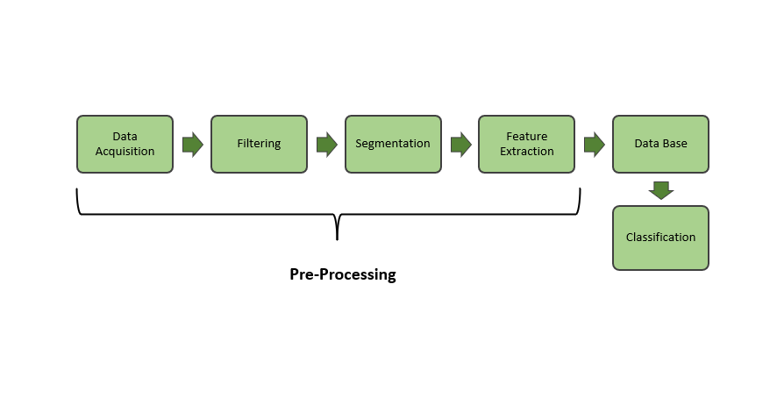

Figure ‎6‑1 – Progress Flow Chart

## Data Acquisition

The EMG signals were simultaneously measured from 3 different hand muscles during 10 hand movements in 7 subjects using surface electrodes and a BIOPAC system, as illustrated in Figure ‎6‑2, Figure ‎6‑3 and Figure ‎6‑4. The signals were recorded at a sampling rate of 1000 Hz. The experiment involved measuring the hand movements from healthy subjects with a mean age of 40, and the average anthropometric dimensions of all participants are summarized in Table 4.1. Two electrodes were placed on each of the measured muscles —Flexor Digitorum Superficialis, Flexor Pollicis Longus, and Extensor Digitorum — following the schematics provided. The study was approved by the internal ethics committee of Afeka College of Engineering, as documented in Table ‎11‑2, and all participants provided informed consent prior to the measurements.

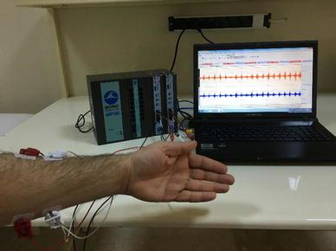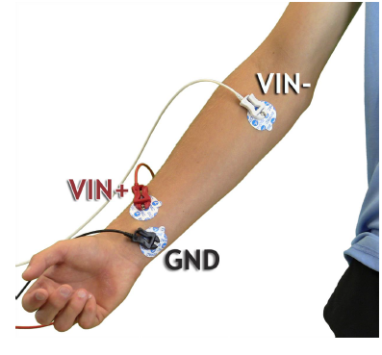

Figure ‎6‑2 – BIOPAC System Set-up

Table ‎6‑1 – Subject Information Range

|  |  |  |
| --- | --- | --- |
| **Information** | **Nomenclature** | **Raw Data** |
| General information | Age [years] | 18-65 |
| Physical Activity [Active, Non-Active] | Active, non-active |
| Gender [Male, Female] | Male, Female |
| Laterality [Right, Left] | Right, Left |
| Anthropometric dimensions [cm] | Total Arm Length - TAL  (from shoulder to wrist) | 50-80 |
| Arm Length - AL  (from shoulder to elbow) | 15-35 |
| Forearm Length – FL  (from elbow to wrist) | 15-35 |
| Maximum Arm Circumference - MAC  (circumference of the thickest part of the arm) | 25-45 |
| Minimum Arm Circumference - mAC  (circumference of the thinnest part of the arm) | 15-35 |
| Maximum Forearm Circumference - MFC  (circumference of the thickest part of the forearm) | 25-35 |
| Minimum Forearm Circumference – mAC  (circumference of the thinnest part of the forearm) | 15-25 |
| Mid Arm Circumference - iAC | 20-40 |
| Mid Forearm Circumference - iFC | 20-30 |

All the dimensions are measured while the muscles are relaxed, not contracted.

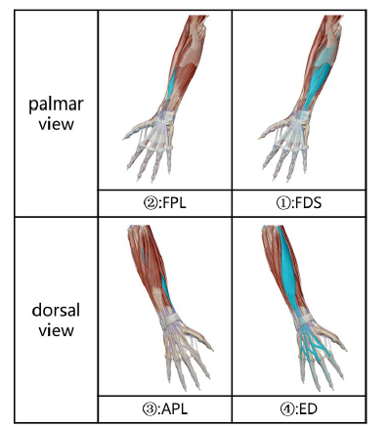

Figure ‎6‑3 – Arm-Hand Muscles Association

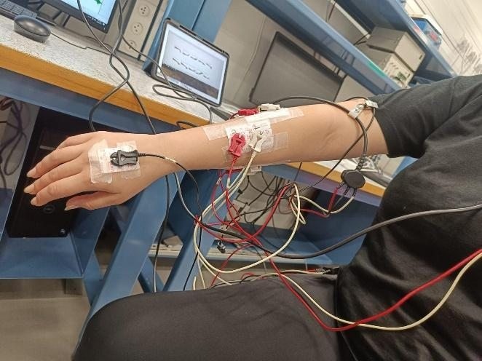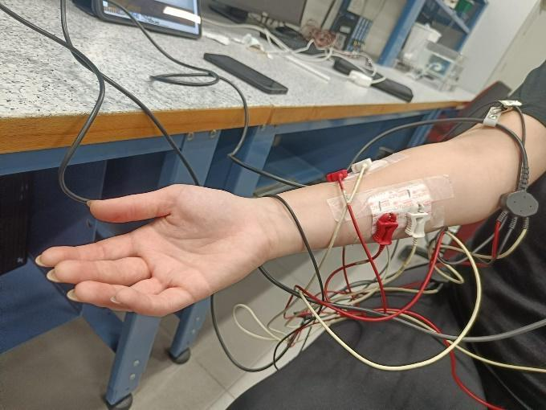

Figure ‎6‑4 – Electrodes Placement

### Experiment Protocol

Each subject performed 50 repetitions of each of the following hand movements: Flexion, Extension, Ulnar Deviation, Radial Deviation, Hook Grip, Power Grip, Spherical Grip, Precision Grip, Lateral Grip, and Pinch Grip, as shown in Figure ‎6‑5 [12]. After measuring 50 repetitions of a movement, the subject rested for about 5 minutes before performing the next movement.

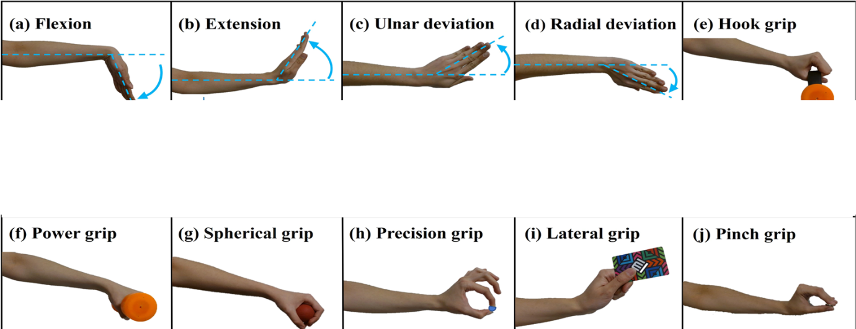

Figure ‎6‑5 – Hand Movements Diagram

## Signal Processing

To prepare the database, all signals were pre-processed offline using Python and Object-Oriented Programming (OOP). All the acquired subject’s signals were organized in a data structure called “Person”, to assign each subject to their own class object to enable simple access to their names, and recorded data as well as create different attributes that divide the data into movements, templates for the features to be stored, separate raw and filtered measurements, and various methods to obtain information about the subject’s data.

### Pre-filtering and Segmentation

The data was imported into Python and converted into a matrix using the Numpy library. Using the summary of data from BIOPAC, the arrays were sliced according to their corresponding hand movements and saved as MATLAB files. For the segmentation of the signals there was no use of any filters. The segments were cut manually to produce more accurate and supervised results. In MATLAB, each individual recording was manually segmented using the ‘**ginput**’ function, and the time stamps were saved in an Excel sheet. These were then put back into Python and used to segment the arrays accordingly. A Python dictionary was created to store all the segmented data for each subject and each movement, with a total of 45 segments per movement. The dictionary was then saved as a binary file using the Pickle library for time-saving reasons. This approach ensured that each segment accurately reflected the intended movement, thereby increasing the reliability of the data used in subsequent analyses. Figure ‎6‑6 shows an example of EMG segmentation of Extension movement., where (a) is the raw signal, (b) the envelope of the signal and (c) the active region of the signal, meaning the relevant part of the signal.

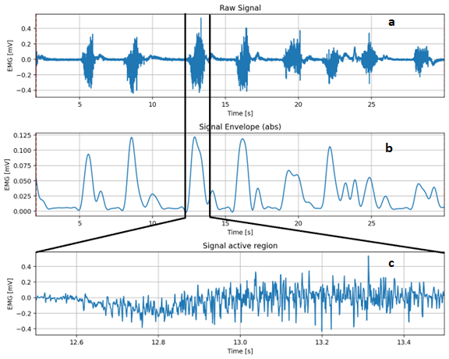

Figure ‎6‑6 – Data Segmentation steps: (a) Raw signal, (b) Signal Envelope, (c) Signal active region

Following the manual segmentation and classification, it could be observed that the movement Pinch Grip was not well-represented in the data, leading to inconsistencies in the classification results. Consequently, the Pinch Grip movement was excluded from further analysis.

### Feature Extraction

In the frequency domain, an STFT (Short-Time Fourier Transform) was applied, with a window size of 256 samples and overlap of 128 samples to produce a matrix for each segment, containing all the frames and their respective frequency distribution.

The data was then rearranged into a dictionary that was divided into hand movements, domain, features, subject names, and the values of the features that were extracted. Figure ‎6‑7 shows an example of the spectrogram of a single segment taken from the Precision Grip movement.

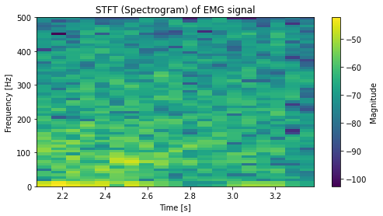

Figure ‎6‑7 – Spectrogram of a single segment EMG

## Machine learning model

For classification, there were 4 machine learning models that were utilized in this project. SVM, KNN (with k equals 5), RF and Voting classifier model (ensemble of the previous 3 models weighted equally). Before the implementation of the model the feature space of the data went under dimensionality reduction of type LDA (Linear Discriminant Analysis) that reduced the dimensions of the feature space from several dozen thousand to 9 features. The voting classifier (Ensemble) used was composed of an ensemble of the three classifiers mentioned above, each contributing equally (one-third weight) to the final decision.

The cross-validation algorithm that was used utilizes the randomness of the classification data split. In the classification algorithm, a function that splits the data into training and testing in respective ratios of 0.8 and 0.2 was included. This separation is random and results in different data each time the algorithm was run. The cross-validation algorithm consists of a loop of 10 iterations, where each saves the different results to create a list. These results are then averaged, and the standard deviation across these results was calculated. At the end one average result table for each subject with the standard deviations was obtained, and 10 different confusion matrices, for the subject specific classification model. The same method is applied to the second classification model where the data of all the subjects is combined to a single data frame and then being split into training and testing data.

The classification process consisted of two stages: preparation and classification. The preparation stage involved taking the data from the STFT binary file and transforming the signals into a data frame using the Pandas library. Custom functions were used to assign the label at the end of the signal, take the absolute value of the signals, and pad the signals with zero values to match the length of the maximum signal length to create a properly sized frame. Each subject was then assigned their own data frame with all the signals from all the movements concatenated, and an additional frame was created with all the signals altogether. Linear Discriminant Analysis (LDA) was applied to reduce the number of features in the frame to a maximum value of the number of classes (9). The model training involved scaling the data, encoding the labels, and running the data through each classifier and the ensemble. The results included Accuracy, F1score, AUC (Area Under Curve), and a confusion matrix for each model and the ensemble. These results were averaged over multiple iterations to provide robust performance metrics. Additionally, a figure of the ROC (Receiver Operating Characteristics) curve of the ensemble was returned using the Matplotlib library.

The classification methods mentioned above were implemented in two models of classification: subject-specific model and general model.

### Subject-Specific - Classification of hand movements of a subject based on its own data

The first classification model was of one subject’s data that was split randomly into training and testing sets. This process was repeated for each subject individually and the results were compared and averaged.

### General - Classification of hand movements of all subjects

The second model included mixing all the subjects’ data into one set and then splitting it into training and testing. And then evaluating the results in the same way as the previous model.

# Results

## Raw Data

Measurements of 10 different hand movements were taken, with 50 repetitions each, from 7 subjects. The measurements were recorded using the BIOPAC EMG system. Figure ‎7‑1 through Figure ‎7‑10 show examples of raw EMG signals acquired from one subject (subject 4) during each of the 10 movements measured from the Flexor Digitorum Superficialis (FDS) (CH1), Flexor Pollicis Longus (FPL) (CH2), and Extensor Digitorum (ED) (CH3) muscles. From these results, a clearer picture is formed of the muscles and their role in the movements of the hand. For example, in Figure ‎7‑2 the FDS is less active than the rest, as well as in Figure ‎7‑1. Variations in signal magnitude can be noticed between different movements such as Power Grip and Pinch Grip mainly in the ED in Figure ‎7‑6 and Figure ‎7‑10, as well as in Ulnar Deviation and Lateral Grip (Figure ‎7‑3 and Figure ‎7‑9). These differences in muscle activities demonstrate the ability to classify different hand motions based on EMG signals.

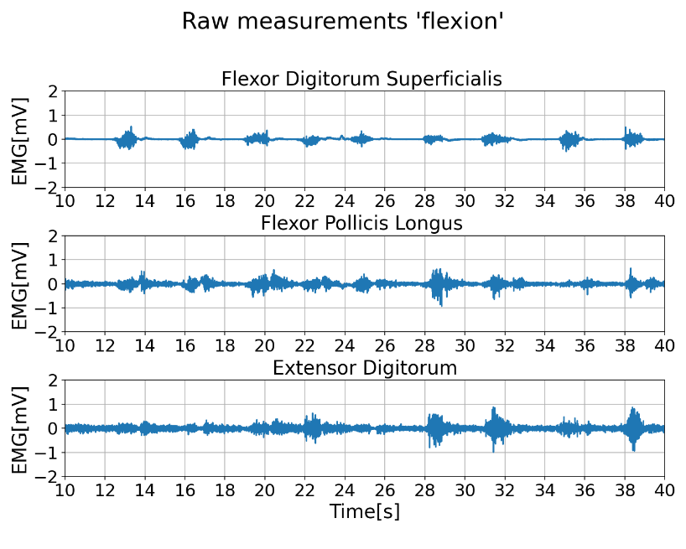

Figure ‎7‑1 – Raw Data Section, Flexion

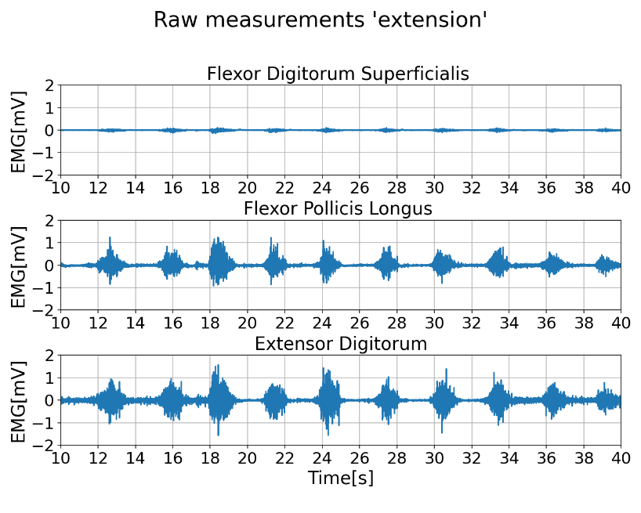

Figure ‎7‑2 – Raw Data Section, Extension

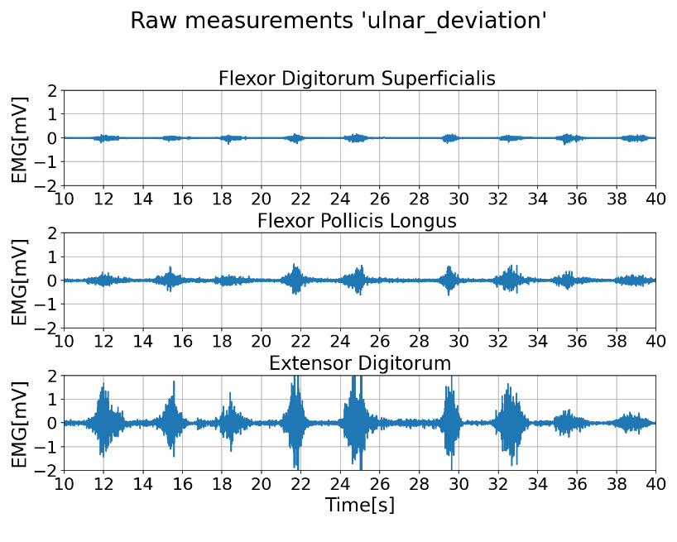

Figure ‎7‑3 – Raw Data Section, Ulnar Deviation

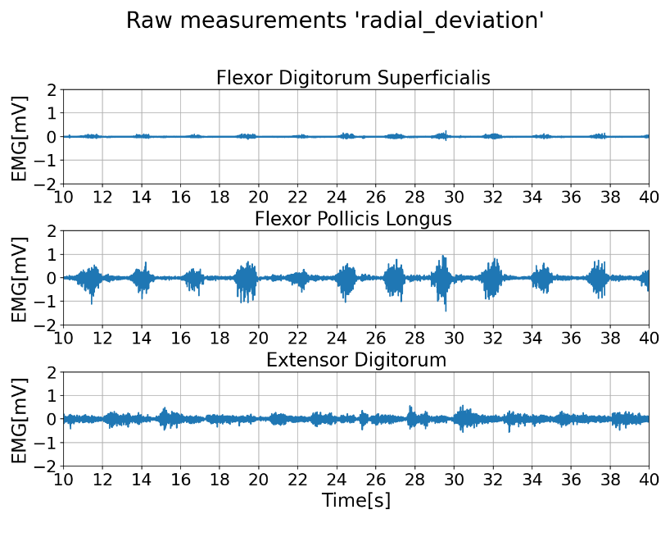

Figure ‎7‑4 – Raw Data Section, Radial Deviation

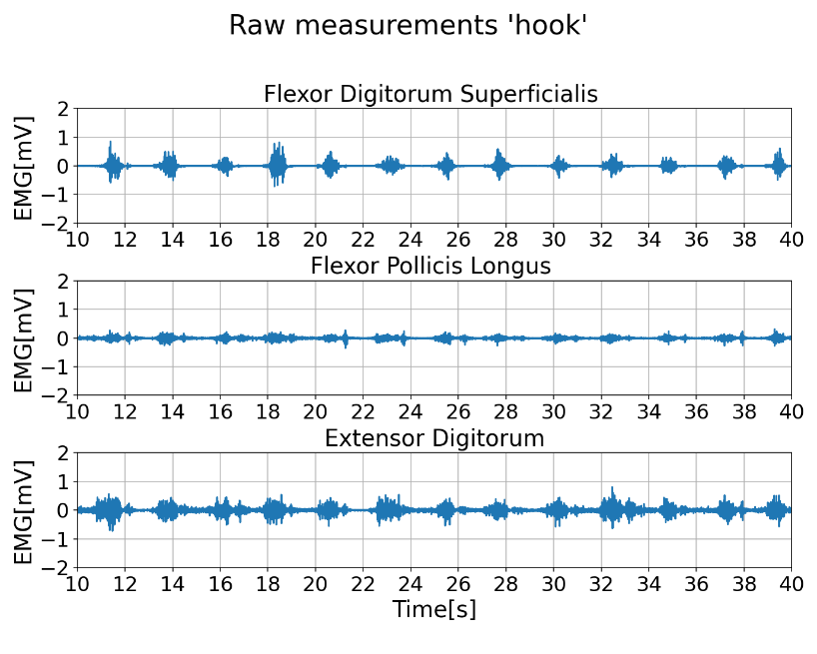

Figure ‎7‑5 – Raw Data Section, Hook Grip

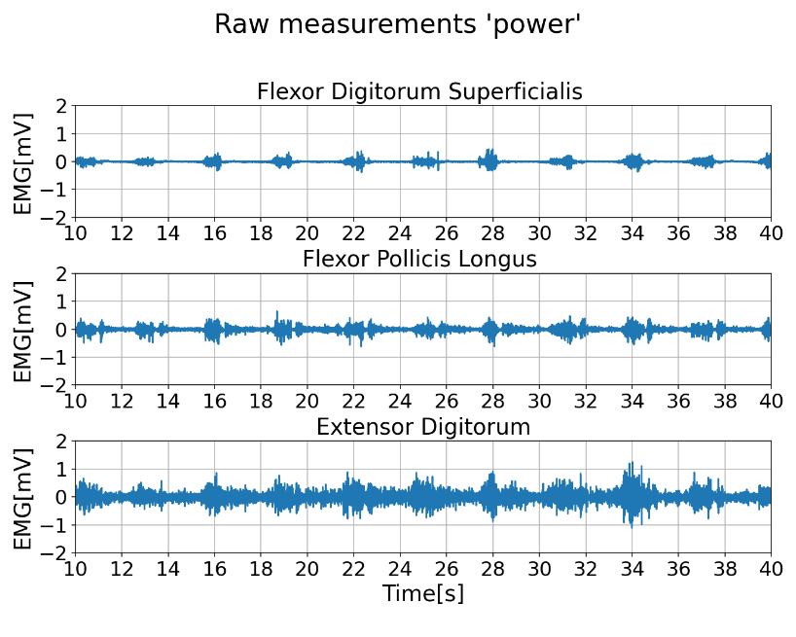

Figure ‎7‑6 – Raw Data Section, Power Grip

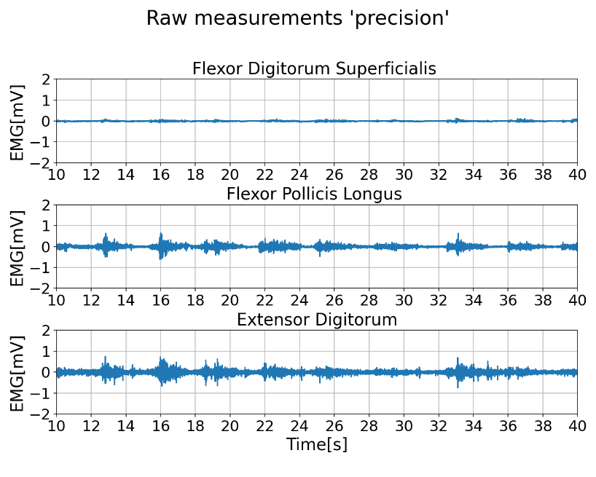

Figure ‎7‑7 – Raw Data Section, Precision Grip

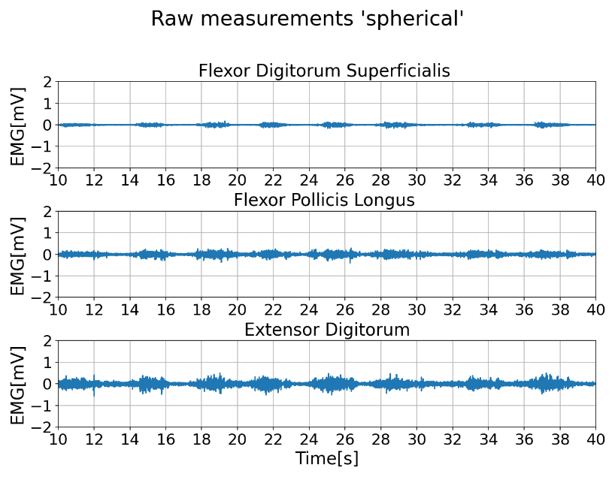

Figure ‎7‑8 – Raw Data Section, Spherical Grip

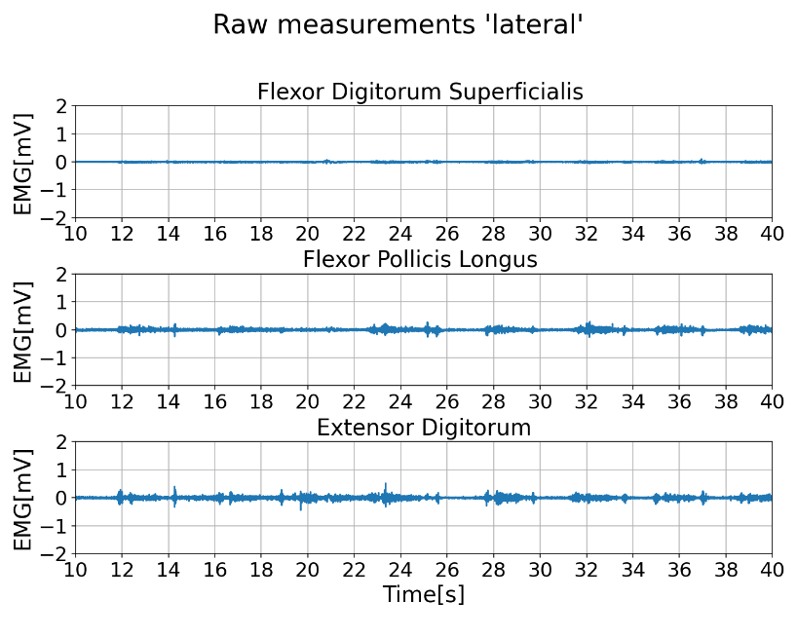

Figure ‎7‑9 – Raw Data Section, Lateral Grip

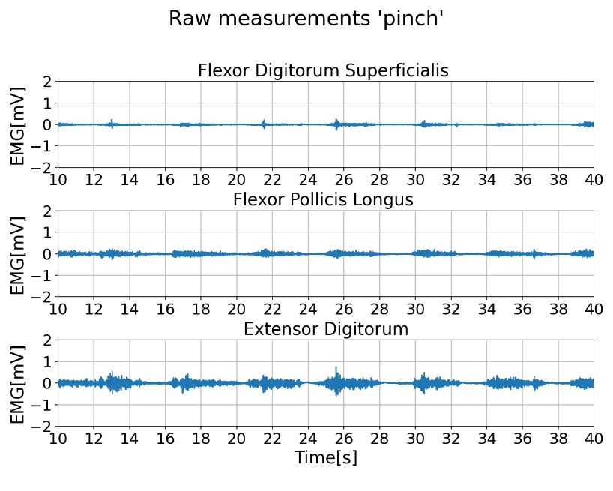

Figure ‎7‑10 – Raw Data Section, Pinch Grip

## Classification Results

The results from both models were analyzed and compared to determine the effectiveness of subject-specific versus general models in recognizing hand movements based on EMG signal. The results consist of tables that summarize the average values and standard deviation for each score (AUC, F1score and Accuracy) for each classifier (SVC, RF, KNN and Ensemble), for each subject - per subject and per movement, a table of averaged values for each score for each classifier of all the subjects' data combined, a table of averaged results for the combined data per movement, graphs that visually show the differences between the values obtained in all the previously mentioned tables, ROC curves for each subject and all subjects combined across each of the 9 movements and LDA scattering of the 9 movements for each subject.

### Subject-Specific Model Results

In the subject-specific model, 4 different classifiers (SVC, RF, KNN and Ensemble) were applied to classify hand movements based on EMG signals. The results were recorded across multiple subjects, and the performance of these classifiers was evaluated using key metrics such as AUC, F1score, and Accuracy, all of which are presented with their standard deviations to account for variability. Table ‎7‑1 and Table ‎7‑2 display the values obtained for the different classifiers with their standard deviation, per subject and per movement respectively, for the subject specific model.

Table ‎7‑1 provides a comprehensive summary of the average performance metrics (AUC, F1score and Accuracy) for each classifier across all subjects, along with the standard deviations, indicating the consistency of these metrics. The highest AUC (0.9938±0.007) was obtained for the RF classifier and the lowest AUC (0.9569±0.0102) was obtained for the KNN classifier. The highest Accuracy (0.9543±0.0257) was obtained for the Ensemble classifier, demonstrating its strong ability to distinguish between different hand movements across all subjects. The lowest Accuracy (0.7914±0.0382), as well as the lowest F1score (0.7913±0.0377) were obtained for the KNN classifier. The F1score, which balances precision and recall, was also highest for the Ensemble classifier (0.9543±0.0258), suggesting that this model effectively reduces both false positives and false negatives. The results reinforce the advantage of combining multiple classifiers to improve overall performance.

Table ‎7‑2 describes the performance of each classifier by specific hand movements, offering insights into how well each classifier performed on individual tasks. The highest AUC (0.9945±0.006) was obtained for the Spherical Grip movement (KNN) and the lowest AUC (0.9552±0.0422) was obtained for the Lateral Grip movement (RN). The highest Accuracy (0.99±0.0059) was obtained for the Spherical Grip movement (Ensemble) and the lowest Accuracy (0.9587±0.0153) for the Lateral Grip movement (Ensemble). The highest F1score (0.9451±0.0318) was obtained for the Spherical Grip movement (Ensemble) and the lowest F1score (0.8053±0.0847) for the Lateral Grip movement (RF). The results show that some hand movements like the Spherical Grip movement, can be more easily and accurately recognized than others. The Ensemble model consistently performed well across all movements, highlighting its robustness in varying conditions and showing the advantage of combining multiple classifiers.

Table ‎7‑1 – Summary of average ±SD of the AUC, F1score and Accuracy obtained for each subject by each of the classifiers for multiclassification of different hand movements for the subject-specific model

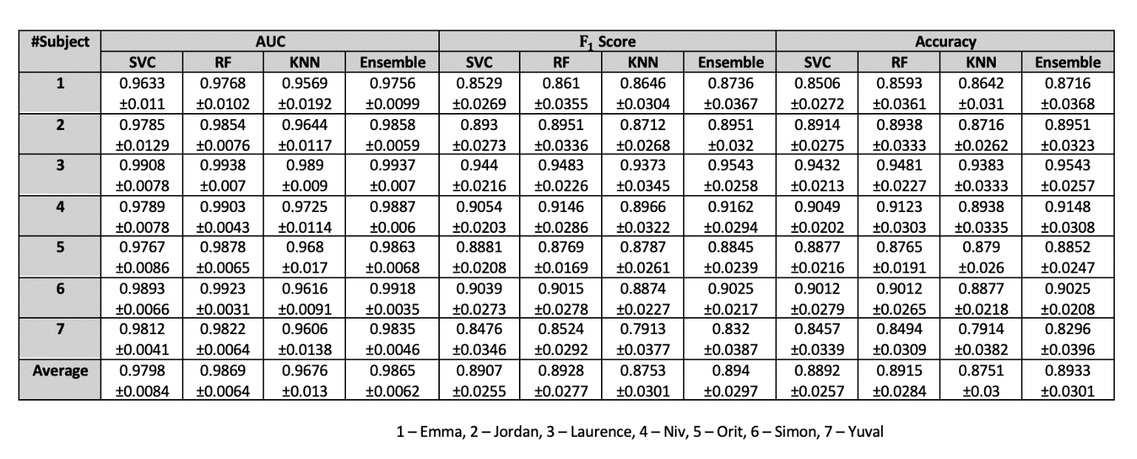

Table ‎7‑2 – Classifiers values and standard deviation (±SD) for each movement for the subject specific model

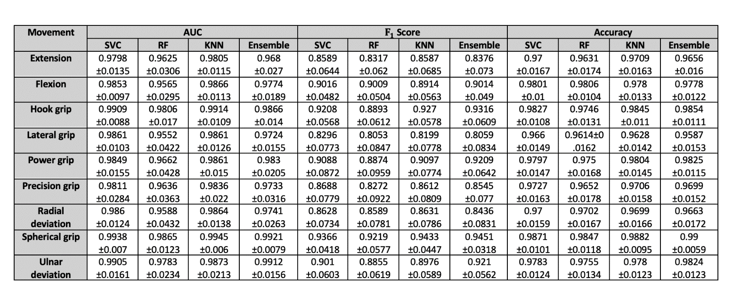

Figure ‎7‑11 to Figure ‎7‑24 display bars charts for each of the 7 subjects for the 4 different classifiers (SVC, RF, KNN and Ensemble) for each metric (AUC, F1score, and Accuracy) for the overall data and per movement. Figure ‎7‑11, Figure ‎7‑13, Figure ‎7‑15, Figure ‎7‑17, Figure ‎7‑19 and Figure ‎7‑21 show that the Ensemble classifier outperformed the other classifiers for subjects 1 to 6, for all metrics. Figure ‎7‑23 shows that for subject 7, both the Ensemble and RF classifiers obtained the best results. Figure ‎7‑12, Figure ‎7‑14, Figure ‎7‑16, Figure ‎7‑18, Figure ‎7‑20, Figure ‎7‑22 and Figure ‎7‑24 confirm the results from Table ‎7‑2 that overall the Spherical Grip movement is the most accurately recognized.

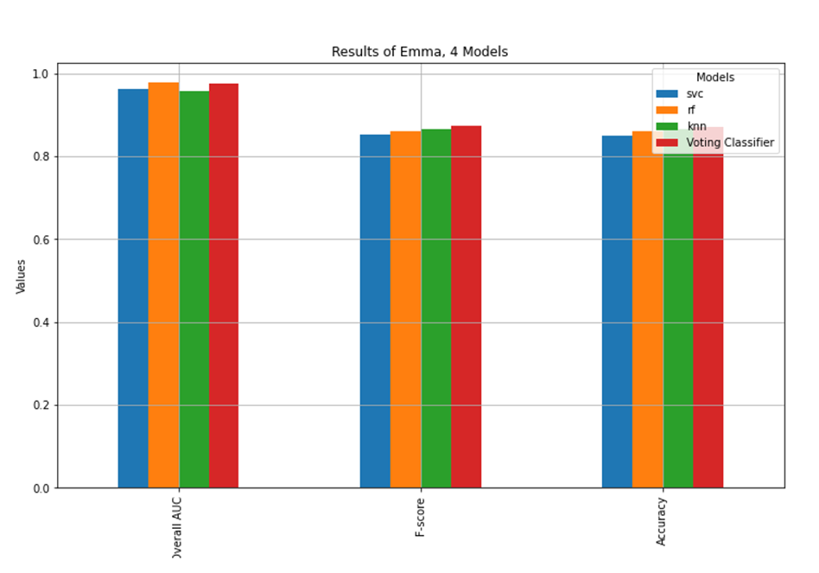

Figure ‎7‑11 – Results for the 4 classifiers, for subject 1

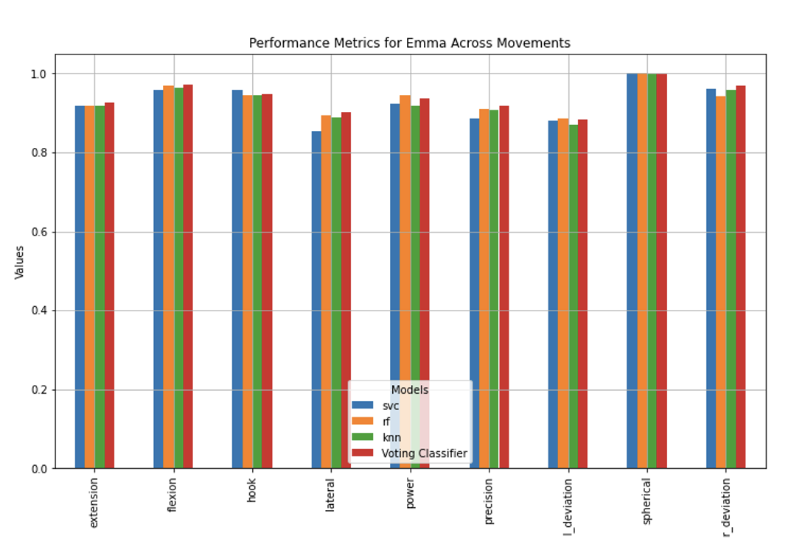

Figure ‎7‑12 – Results for the 4 classifiers across 9 movements, for subject 1

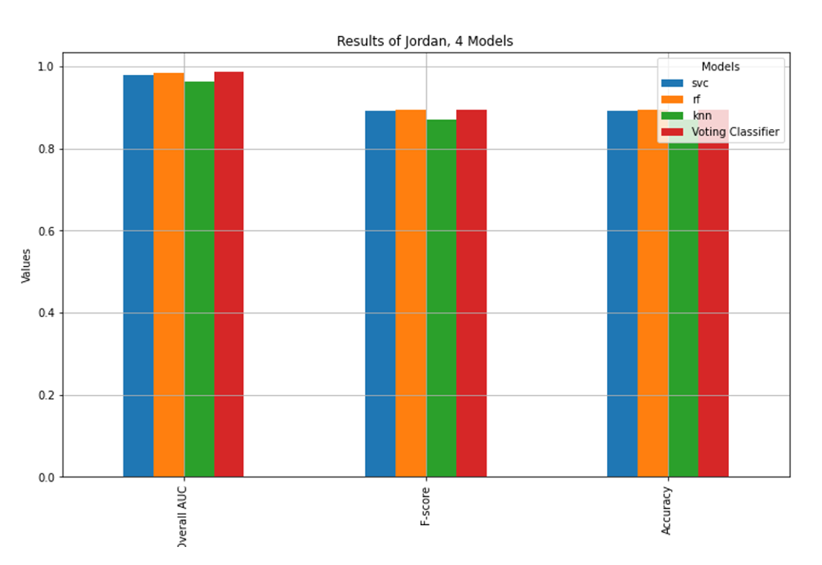

Figure ‎7‑13 – Results for the 4 classifiers, for subject 2

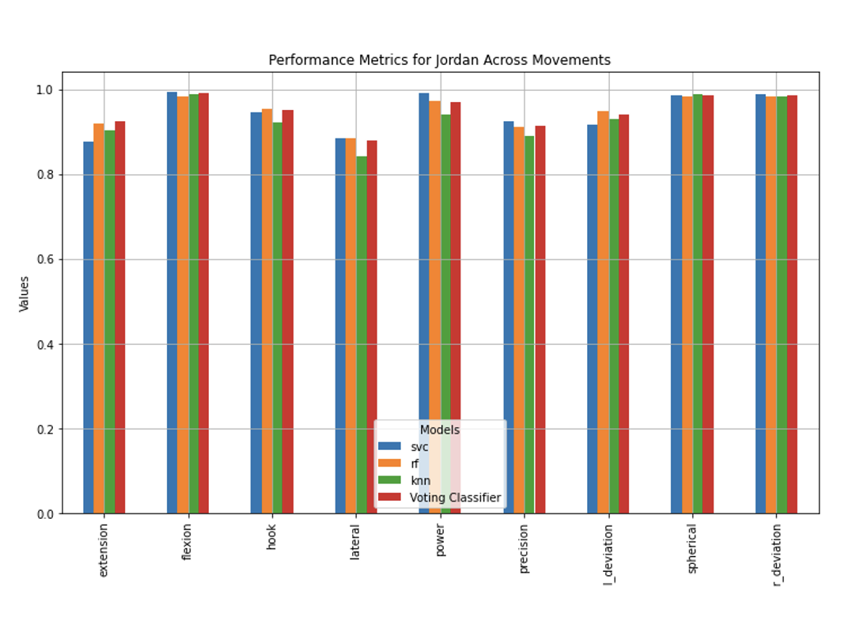

Figure ‎7‑14 – Results for the 4 classifiers across 9 movements, for subject 2

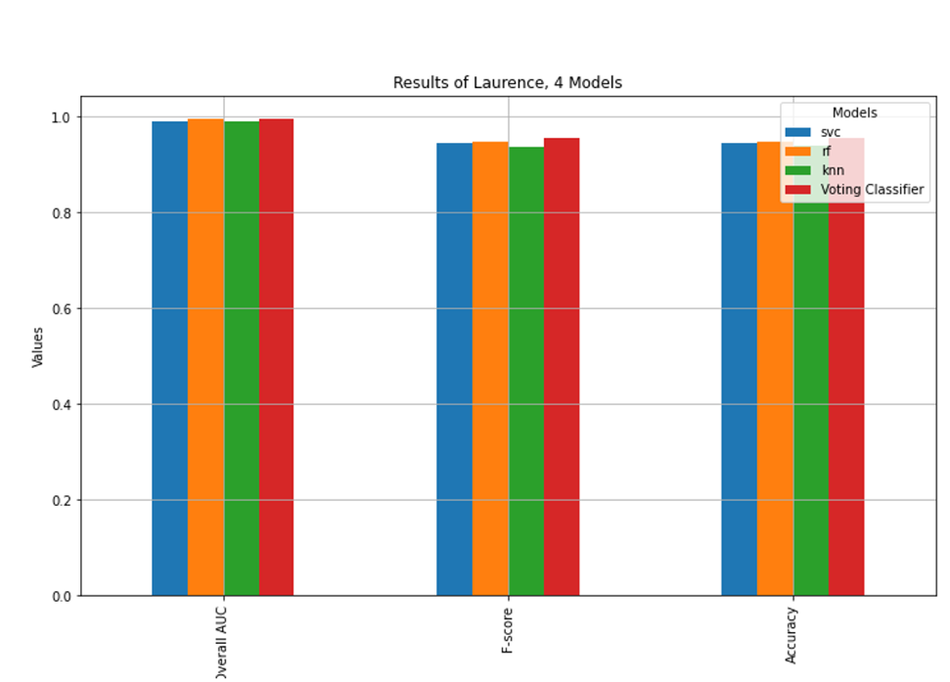

Figure ‎7‑15 – Results for the 4 classifiers, for subject 3

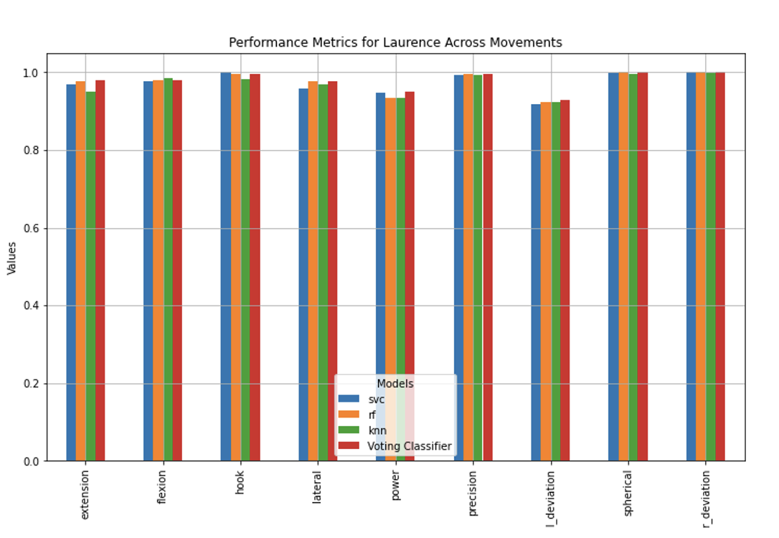

Figure ‎7‑16 – Results for the 4 classifiers across 9 movements, for subject 3

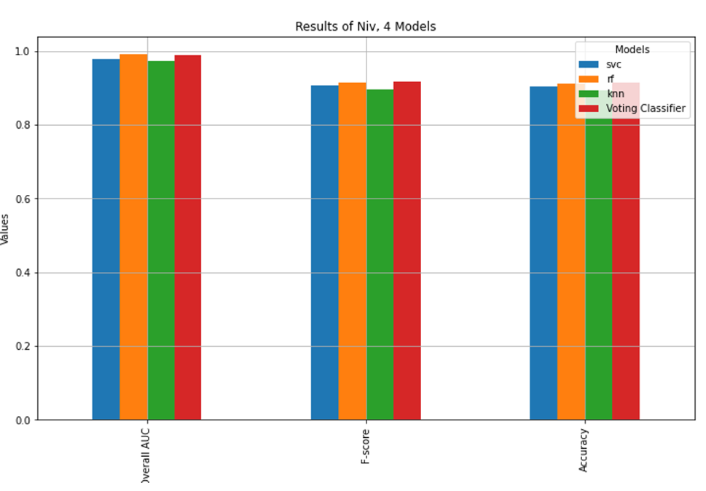

Figure ‎7‑17 – Results for the 4 classifiers, for subject 4

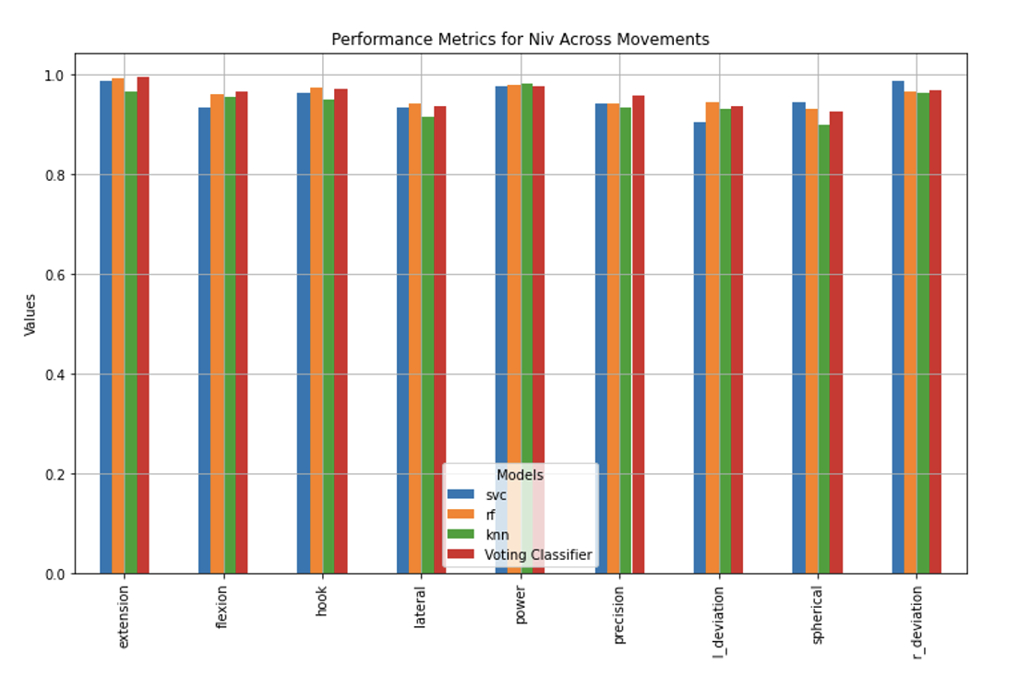

Figure ‎7‑18 – Results for the 4 classifiers across 9 movements, for subject 4

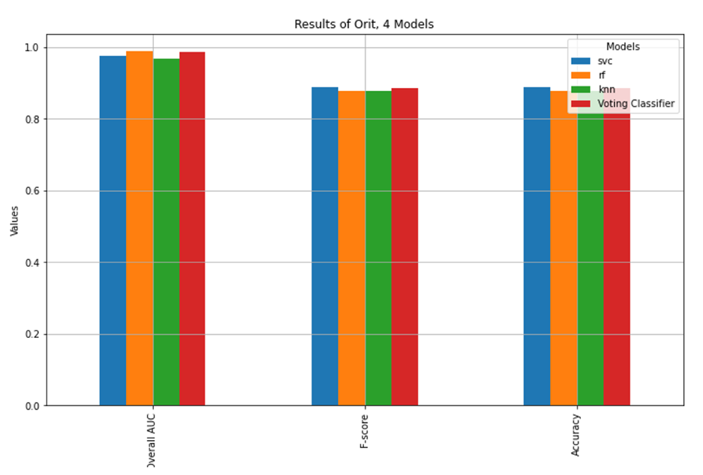

Figure ‎7‑19 – Results for the 4 classifiers, for subject 5

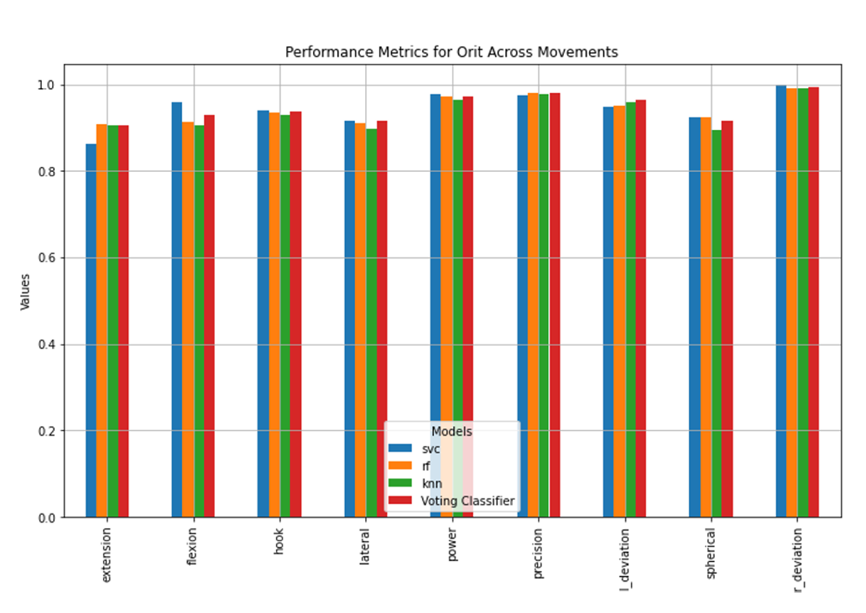

Figure ‎7‑20 – Results for the 4 classifiers across 9 movements, for subject 5

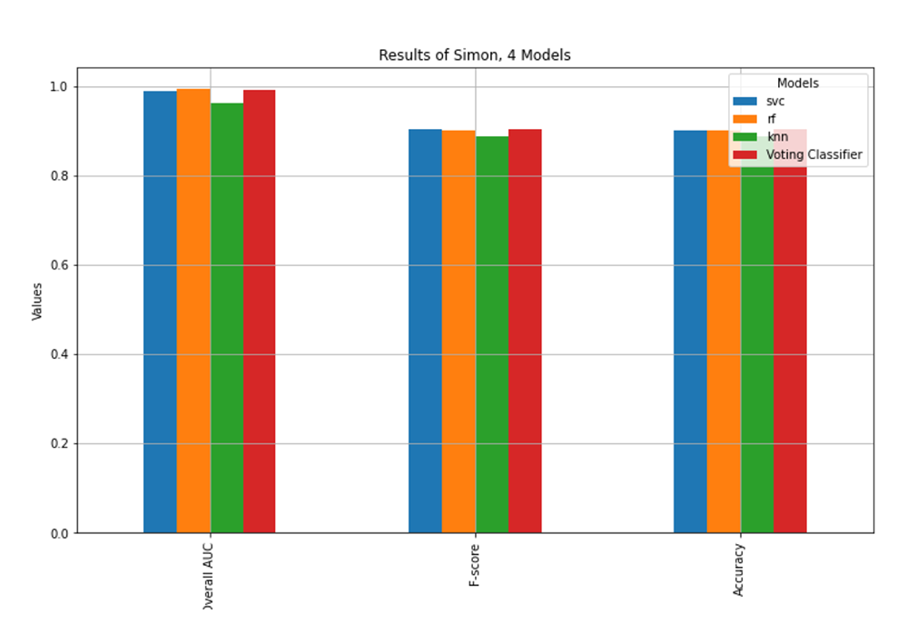

Figure ‎7‑21 – Results for the 4 classifiers, for subject 6

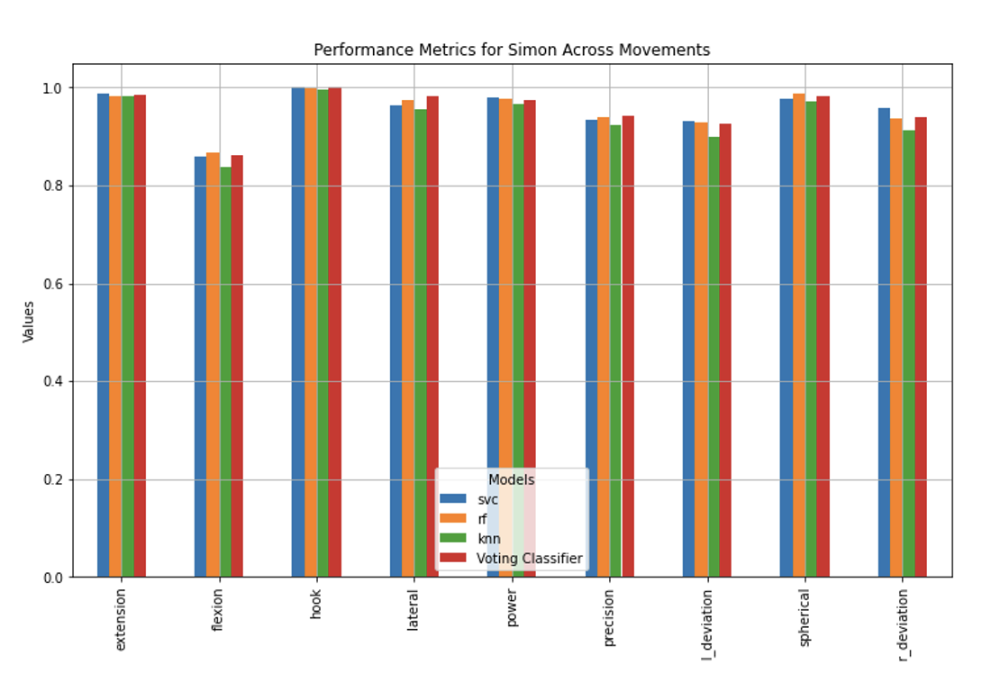

Figure ‎7‑22 – Results for the 4 classifiers across 9 movements, for subject 6

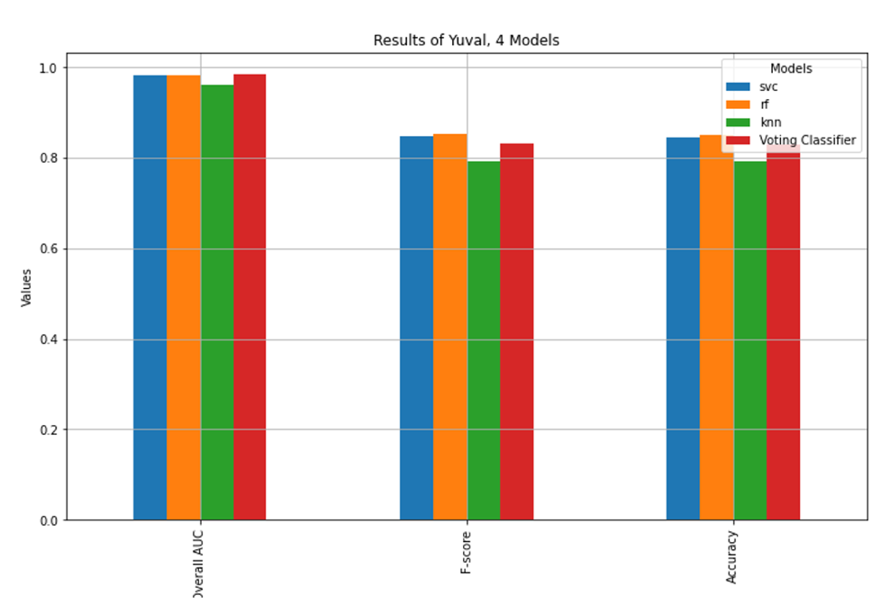

Figure ‎7‑23 – Results for the 4 classifiers, for subject 7

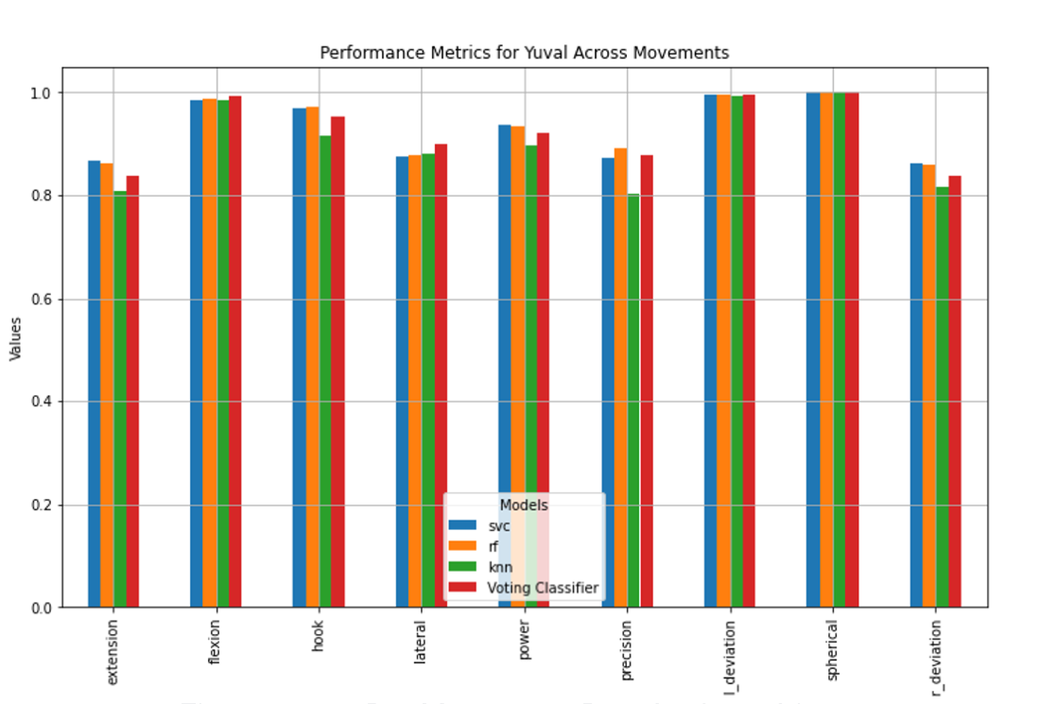

Figure ‎7‑24 – Results for the 4 classifiers across 9 movements, for subject 7

Figure ‎7‑25 to Figure ‎7‑31 display the Receiver Operating Characteristic (ROC) curves for each of the subjects across the 9 hand movements for the voting classifier (Ensemble), providing insights into the sensitivity and specificity of the classifiers. The ROC curves were created by plotting the true positive rate (sensitivity) against the false positive rate (1-specificity) at various threshold settings. The area under the ROC curve (AUC) provides a single measure of overall performance, a higher AUC indicates better performance. The true positive rate (sensitivity) measures the proportion of actual positives that are correctly identified by the classifier. On the ROC curve, this is represented along the y-axis. A high sensitivity indicates that the classifier is effectively identifying the positive cases. The false positive rate measures the proportion of actual negatives that are incorrectly identified as positives by the classifier. This is represented along the x-axis on the ROC curve. A low false positive rate indicates that the classifier is not falsely identifying negatives as positives frequently. The AUC is a summary metric that quantifies the overall ability of the classifier to discriminate between positive and negative classes. An AUC of 0.5 indicates no discriminative power (equivalent to random guessing), while an AUC of 1.0 indicates perfect discrimination. A curve that bows towards the top-left corner of the plot indicates high performance, as it shows high sensitivity and low false positive rates across various thresholds. A curve that stays close to the diagonal (dashed line) suggests that the classifier is no better than random guessing. The ROC curves generated in the project demonstrate that all classifiers (SVC, RF, KNN and Ensemble) performed well, with the curves consistently bowing towards the top-left corner. This indicates that the classifiers have high sensitivity and low false positive rates, meaning they are effective at distinguishing between different hand movements based on EMG signals.

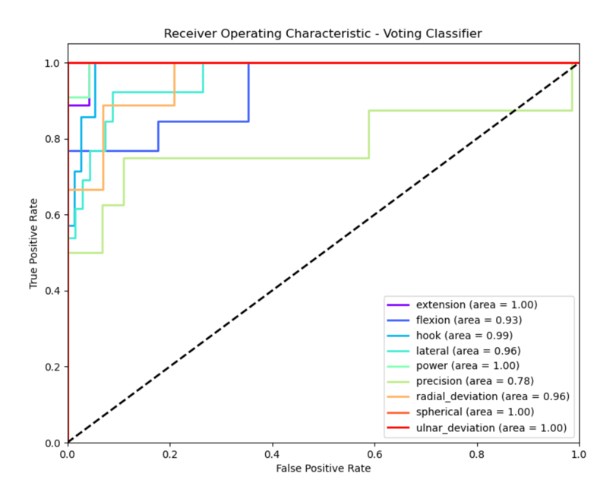

Figure ‎7‑25 – ROC curve across 9 movements, for subject 1

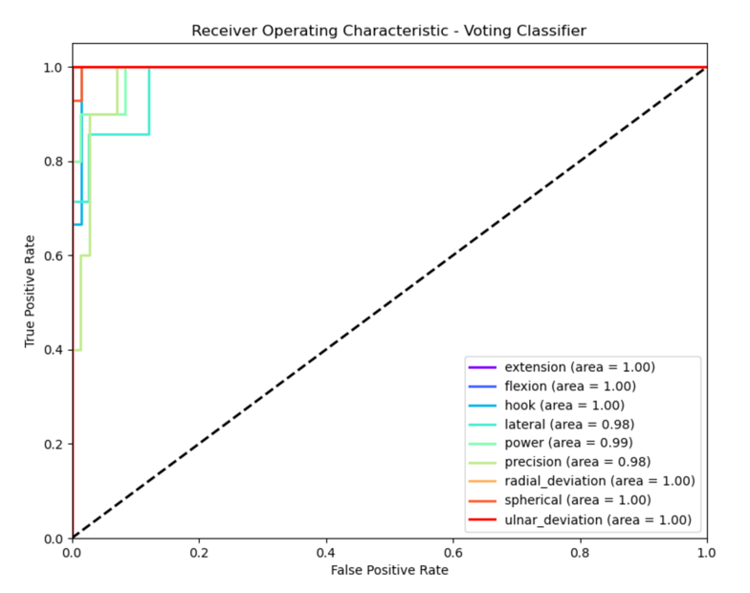

Figure ‎7‑26 – ROC curve across 9 movements, for subject 2

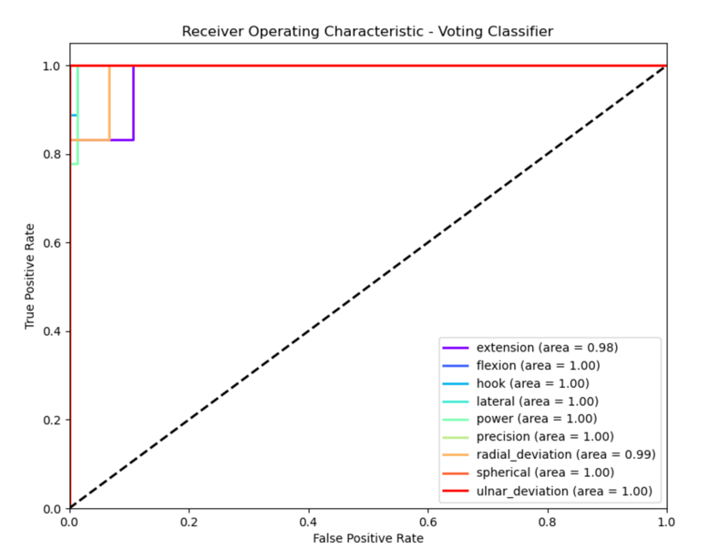

Figure ‎7‑27 – ROC curve across 9 movements, for subject 3

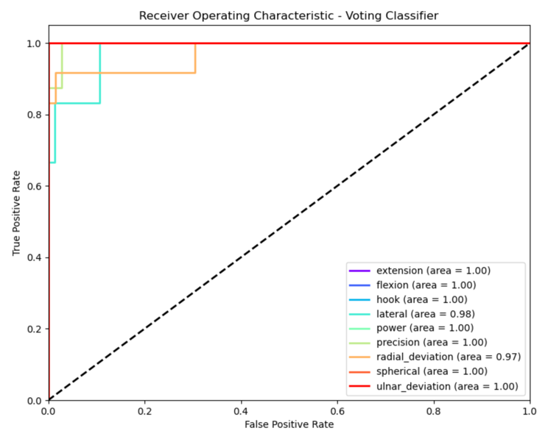

Figure ‎7‑28 – ROC curve across 9 movements, for subject 4

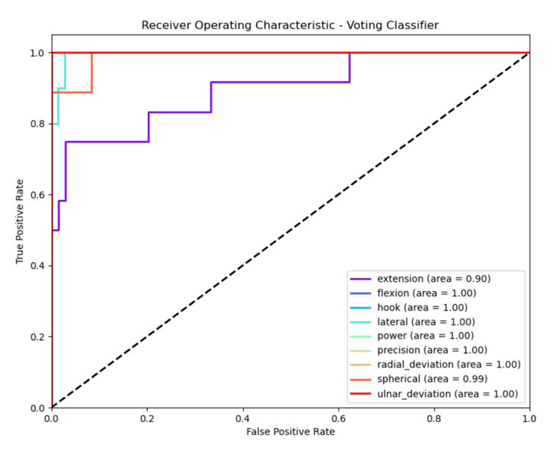

Figure ‎7‑29 – ROC curve across 9 movements, for subject 5

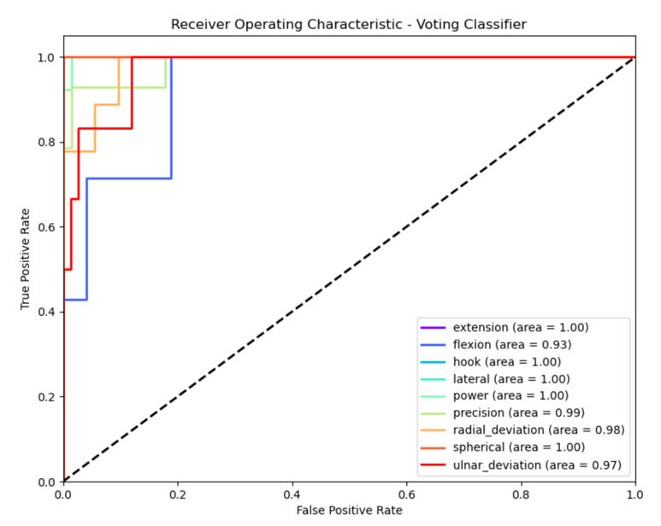

Figure ‎7‑30 – ROC curve across 9 movements, for subject 6

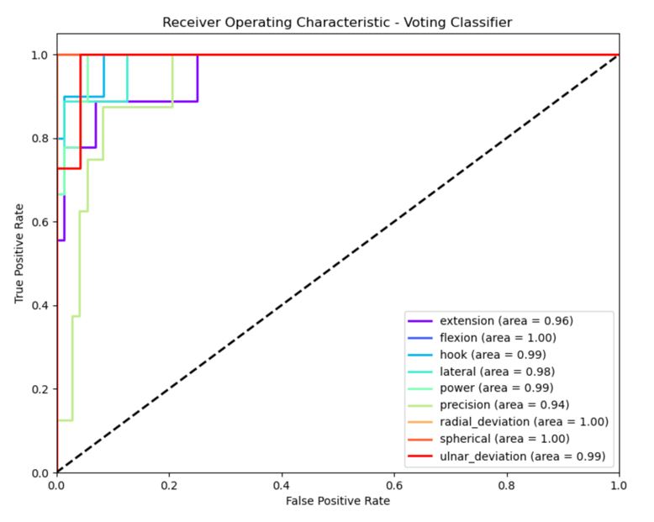

Figure ‎7‑31 – ROC curve across 9 movements, for subject 7

Figure ‎7‑32 to Figure ‎7‑38 display the 3 axes LDA scattering for each subject. Linear Discriminant Analysis (LDA) is a dimensionality reduction technique used to project high-dimensional data into a lower-dimensional space while maximizing the separability between classes. In the context of this project, LDA was applied to the EMG signal features to reduce their dimensionality, making it easier to visualize and classify different hand movements. The primary goal of LDA is to maximize the distance between the means of different classes (in this case, different hand movements) while minimizing the variance within each class. This results in clearer separation between the classes when plotted in a lower-dimensional space. The axes in LDA scatter plots represent the new dimensions or components created by LDA. These components are linear combinations of the original features and are oriented to best separate the classes. In the scatter plots, each point represents an instance of a hand movement, and different colors or markers indicate different classes. Well-separated clusters with minimal overlap suggest that the classes are easily distinguishable, which implies that the classifiers will perform well. Significant overlap between clusters indicates that the classes are not well separated, which could lead to classification errors. The LDA scatter plots in this project effectively reduce the complexity of the EMG data, making it easier to visualize how well different hand movements can be separated based on the extracted features. The plots typically show clear separation between clusters representing different hand movements, indicating that LDA has successfully identified the features that contribute most to class separability. In the scatter plots, clusters corresponding to different hand movements, such as Spherical Grip, are generally well separated with minimal overlap. This strong separation is crucial because it implies that the classifiers (SVC, RF, KNN, and Ensemble) will have an easier time distinguishing between these movements, leading to higher precision and reliability. The LDA scatter plots show varying degrees of separation across different subjects. In some subjects, the clusters are very tight and well-separated, indicating that the LDA model has performed exceptionally well in identifying distinct patterns in the EMG signals. In other subjects, there may be slight overlaps, particularly in more complex movements, such as Ulnar Deviation and Radial Deviation. This variability highlights the challenge of creating a general model that works equally well for all subjects. By reducing the data to a few LDA components, the scatter plots make it easier to visualize and understand the underlying structure of the data. This not only aids in interpreting the classification results but also helps in refining the models by focusing on the most relevant features. The clear separation seen in many of the LDA scatter plots suggests that the EMG signals for different hand movements are distinct enough to be reliably classified by machine learning models. This is particularly important for practical applications, such as controlling prosthetic devices or developing gesture-based interfaces, where precise and accurate movement recognition is critical.

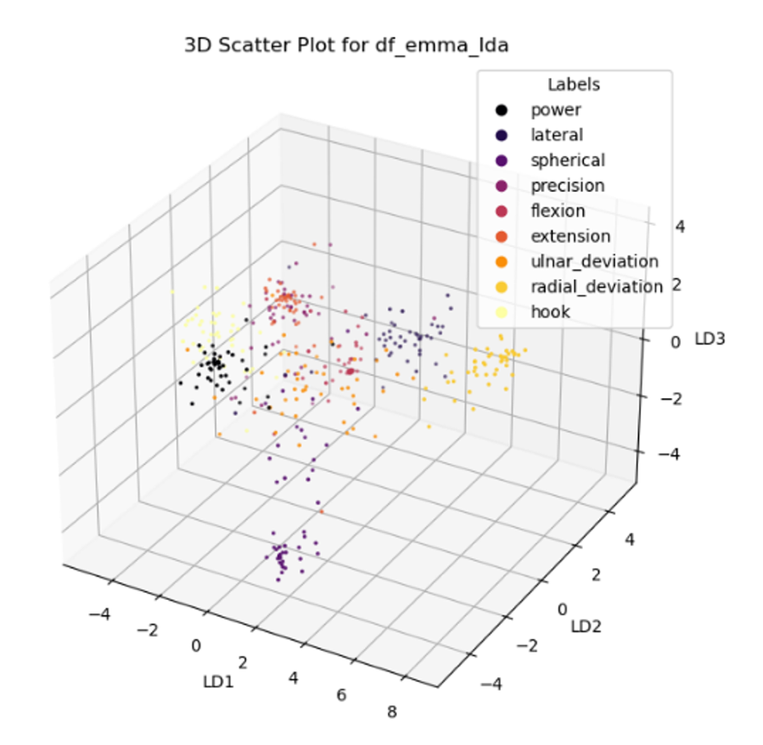

Figure ‎7‑32 – 3 axes LDA scattering for subject 1

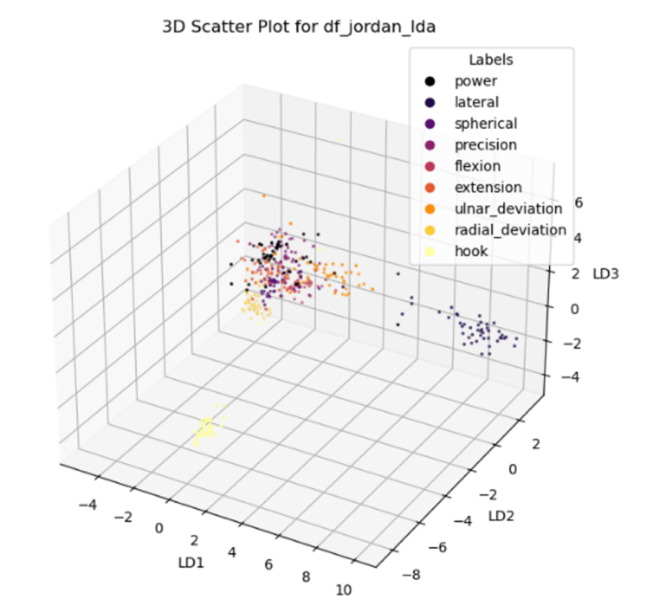

Figure ‎7‑33 – 3 axes LDA scattering for subject 2

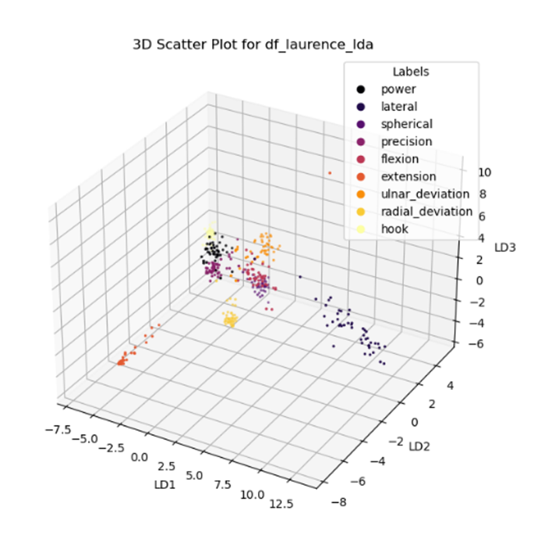

Figure ‎7‑34 – 3 axes LDA scattering for subject 3

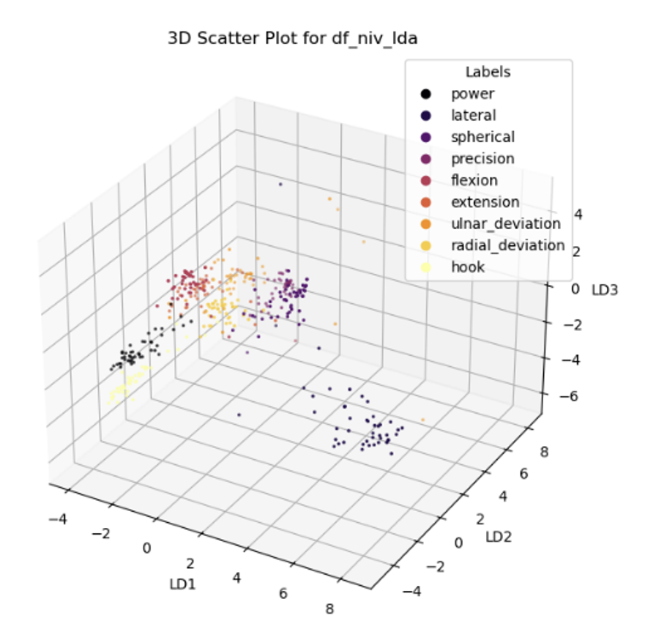

Figure ‎7‑35 – 3 axes LDA scattering for subject 4

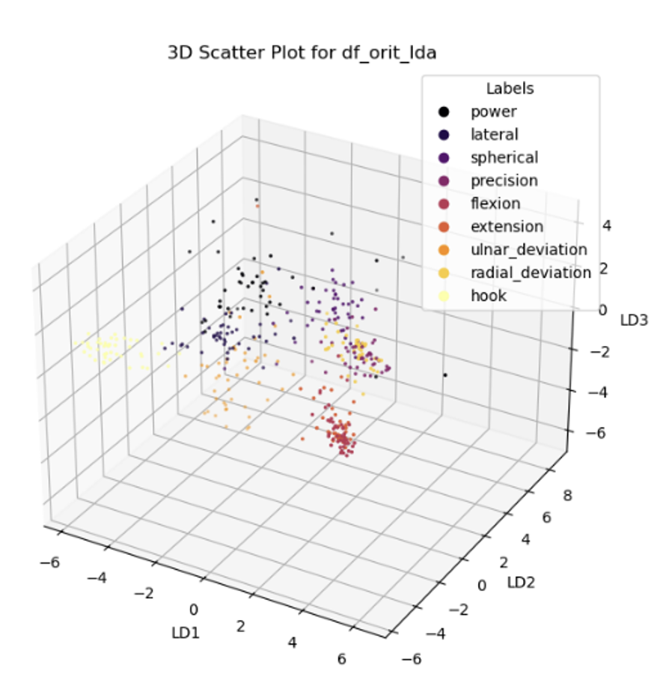

Figure ‎7‑36 – 3 axes LDA scattering for subject 5

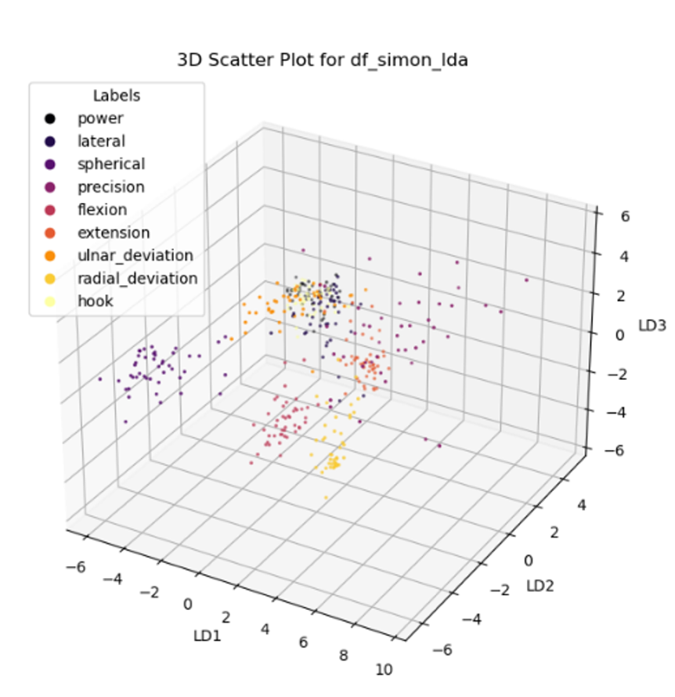

Figure ‎7‑37 – 3 axes LDA scattering for subject 6

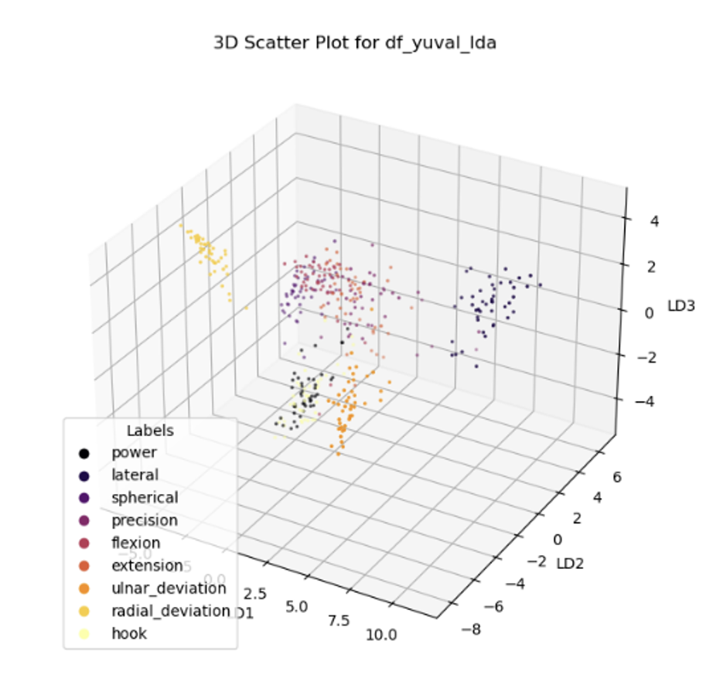

Figure ‎7‑38 – 3 axes LDA scattering for subject 7

### General Model Results

In the general model, data from all subjects was combined, and the classifiers’ performances were evaluated on the mixed dataset. This approach tested the classifiers’ ability to generalize across a more diverse set of EMG signals, representing a broader range of movement patterns. Table ‎7‑3 and Table ‎7‑4 display the values obtained for the different classifiers with their standard deviation, per subject and per movement respectively, for the general model.

Table ‎7‑3 summarizes the overall performance of each classifier on the combined dataset of all subjects, with a focus on the AUC, F1score and Accuracy. The highest AUC (0.9845±0.0057) was obtained for the Ensemble classifier and the lowest AUC (0.9636±0.0077) was obtained for the KNN classifier. The highest Accuracy (0.8543±0.0385) was obtained for the SVC classifier and the lowest Accuracy (0.8074±0.0304) was obtained for the KNN classifier. The highest F1score (0.8571±0.0385) was obtained for the SVC classifier and the lowest F1score (0.8067±0.0313) was obtained for the KNN classifier. The SVC classifier performed well, suggesting that it is highly effective in generalizing new data.

Table ‎7‑4 presents the performance metrics of each classifier broken down by specific hand movements in the general model. It clearly shows that the Spherical Grip movement was the most accurately recognized of the movements, with a value of 1 for almost all the classifiers’ metrics. The AUC values indicate the overall ability of each classifier to distinguish between classes. The Ensemble generally shows high AUC values across all movements, indicating strong classification performance. Notably, for movements like Flexion, Radial Deviation, and Spherical Grip, both SVC and Ensemble classifiers achieve a perfect AUC of 1, indicating near-perfect classification. The standard deviations for AUC are quite low, which suggests that the performance of the classifiers is consistent across different iterations. The Ensemble model tends to have a lower F1score compared to its AUC, particularly for more complex movements like Extension and Ulnar Deviation. This indicates that while the classifier is good at distinguishing between classes overall, there might be a slight trade-off in terms of balancing false positives and false negatives. The Accuracy values indicate the proportion of correct classifications made by each model. The Ensemble model generally shows high Accuracy, especially in movements like Flexion, Radial Deviation and Spherical Grip, where it either matches or slightly outperforms the individual classifiers.

Table ‎7‑3 – Classifiers values and standard deviation (±SD) for the general model

|  |  |  |  |
| --- | --- | --- | --- |
|  | **AUC** | **F1score** | **Accuracy** |
| **SVC** | 0.9809±0.0105 | 0.8571±0.0385 | 0.8543±0.0385 |
| **RF** | 0.9828±0.0065 | 0.8411±0.04 | 0.8395±0.042 |
| **KNN** | 0.9636±0.0077 | 0.8067±0.0313 | 0.8074±0.0304 |
| **Ensemble** | 0.9845±0.0057 | 0.8398±0.041 | 0.8383±0.0425 |

Table ‎7‑4 – Classifiers values and standard deviation (±SD) for each movement for the general model

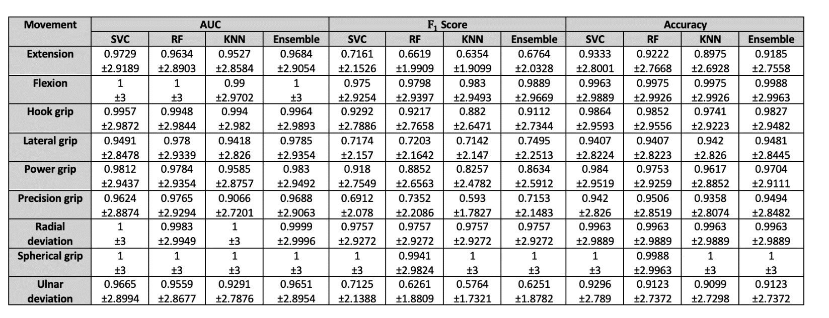

Figure ‎7‑39 and Figure ‎7‑40 display bars charts for all subjects combined for the 4 different classifiers (SVC, RF, KNN and Ensemble) for each metric (AUC, F1score, and Accuracy) for the overall data and per movement. Figure ‎7‑39 shows that the Ensemble classifier outperformed the other classifiers for all metrics. Figure ‎7‑40 confirms the results from Table ‎7‑4 that overall, the Spherical Grip, Flexion and Radial Deviation movements are the most accurately recognized.

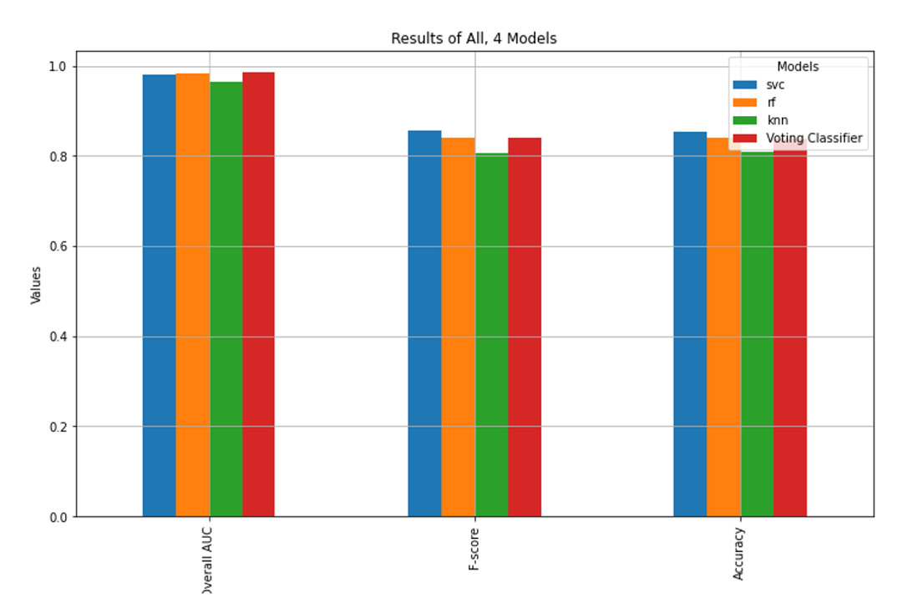

Figure ‎7‑39 – Results for the 4 classifiers, for all subjects combined

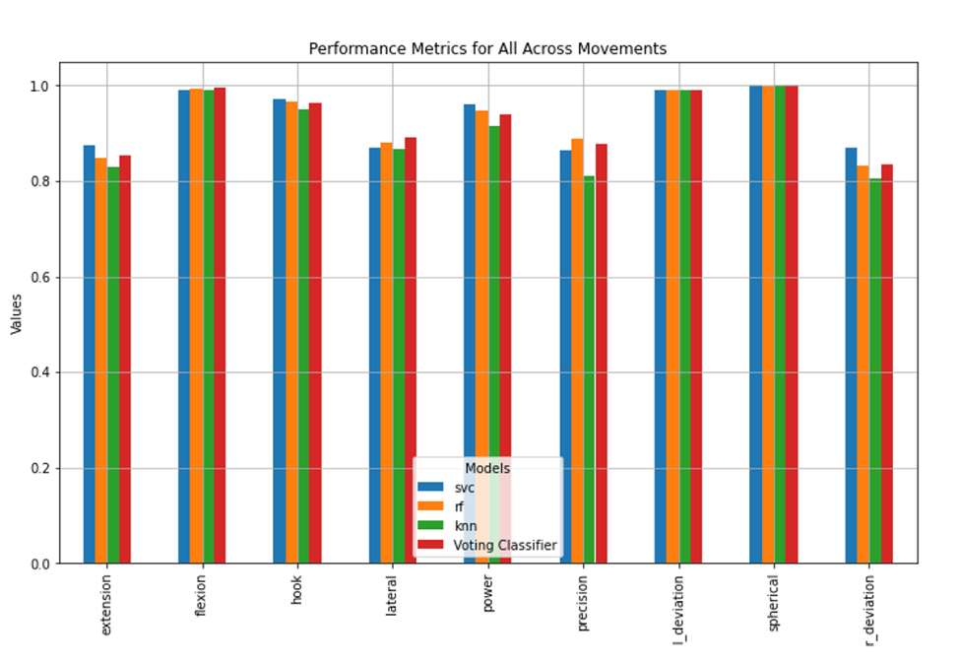

Figure ‎7‑40 – Results for the 4 classifiers across 9 movements, for all subjects combined

Figure ‎7‑41 displays the ROC curve for all subjects combined. The ROC curves are close to the top-left corner of the plot, indicating high sensitivity and low false positive rates, which reflects the strong performance of the classifiers in distinguishing between different hand movements.

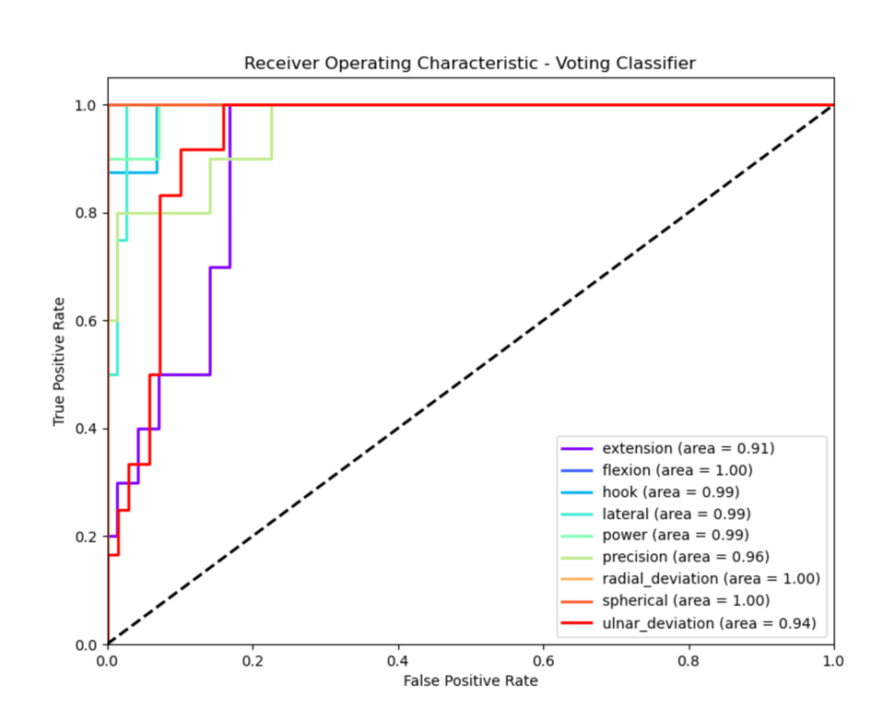

Figure ‎7‑41 – ROC curve across 9 movements, for all subjects combined

The analysis of hand movement classification using EMG signals demonstrated that the Ensemble model consistently outperforms individual classifiers (SVC, RF and KNN) in both subject-specific and general models. The Ensemble model achieved the highest Accuracy and AUC, showing its robustness in handling variations across subjects and movements. While SVC and RF also performed well, particularly in distinguishing specific hand movements, KNN lagged, especially in more complex tasks. The LDA scatter plots confirmed that the Ensemble model and SVC provided better class separability. Although the general model's performance was slightly lower than the subject-specific model, the Ensemble model still maintained strong Accuracy and AUC, proving its effectiveness in generalizing across subjects.

# Discussion

## Discussion on the values obtained

The values derived from the classification models provide critical insights into the efficacy of the methodologies employed for the classification of hand movements based on EMG signals. The subject-specific model achieved an overall precision of 91.9%, and a precision of 94.6% per class, underscoring its strong capability to differentiate between various hand movements within individual subjects. This high precision is attributable to several key methodological factors, including the manual segmentation of EMG signals, the selection of robust classifiers, and the strategic implementation of feature extraction and dimensionality reduction techniques. The general model, which was trained on the aggregated data from all subjects, achieved an overall precision of 88.3% and a precision of 92.3% per class. This achievement is commendable, given the challenges posed by inter-subject variability. EMG signals are highly individualized, with variations influenced by factors such as muscle anatomy, skin impedance, and electrode placement. The general model's strong performance across a diverse set of subjects indicates that the feature extraction and classification techniques were effective in capturing the essential characteristics of the EMG signals, despite these variabilities. If both models are combined and are taken into consideration both the overall precision and the precision per class, an overall precision of 91.8% for the whole classification process is obtained.

In Figure ‎8‑1, the performance metrics can be observed for the subject-specific model (blue) and for the mixed data model (orange), where the AUC, Accuracy and F1score distributions are presented. These metrics highlight the models’ high accuracy and reliability in classifying hand movements based on EMG signals.

The performance of the subject-specific model is further elucidated through key metrics such as the F1score, the AUC and the Accuracy. For the subject-specific model, the average F1score across the four classifiers is . The F1score is particularly significant as it balances precision (the capacity to minimize false positives) and recall (the ability to maximize true positives), offering a comprehensive measure of the model's effectiveness. The elevated F1score indicates that the model not only achieves high accuracy but also maintains reliability, effectively managing the balance between precision and recall, which is critical in applications such as prosthetics and rehabilitation where both false positives and false negatives may have substantial consequences. The AUC, which averaged $98.02±0.85\%$, further substantiates the model's robustness. The AUC serves as an indicator of the model's ability to distinguish between classes; higher values denote superior discriminatory power. In the context of EMG signal classification, a high AUC suggests that the model can effectively differentiate between subtle variations in EMG patterns associated with different hand movements, even when those differences are not readily discernible by simpler models. The average Accuracy for the first model is $88.73±2.86\%$ and demonstrates the ratio of correctly classified samples to the entire dataset.

The performance of the general model is further illustrated in Figure ‎8‑1 through key metrics such as the F1score, the AUC and the Accuracy. Across the four classifiers, the average F1score is $83.62±4.44\%$, the average AUC is $97.80±0.67\%$ and the average Accuracy is $83.49±4.24\%$. Noticeably, the AUC score is uniquely higher than the rest of the metrics in the general model, which can be an indication to the model’s ability to distinguish negative and positive classes due to its larger data set.

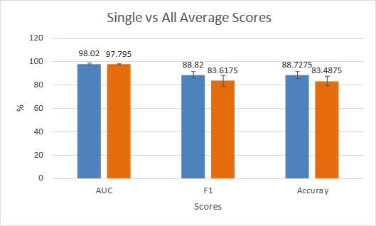

Figure ‎8‑1 – Classifier average results for single VS all average scores

In *Figure ‎8‑2*, the performance metrics can be observed for the subject-specific model (blue) and for the mixed data model (orange) per hand movement (class), where the AUC, Accuracy and F1score distributions are presented. The comparison of AUC, Accuracy and F1score across different hand movements provides a detailed perspective on how the classification accuracy varies with each specific movement. This figure illustrates the models’ performance on movements that are more distinct and easier to classify, such as Spherical Grip, compared to those that might involve subtler muscle activations, like Lateral Grip. A closer examination of the classification performance across individual movements reveals that certain hand movements are classified with higher accuracy than others. This variation can be attributed to the distinctiveness of the EMG patterns associated with different movements. For example, movements involving larger muscle groups or more pronounced muscle contractions, such as the Spherical Grip, tend to generate clearer and more consistent EMG signals, resulting in higher classification accuracy. Conversely, movements like Lateral Grip, which require finer motor control and involve smaller muscle groups, may produce less distinct EMG signals, thereby presenting greater challenges for accurate classification.

Across the four classifiers, the following movement-specific metrics were obtained: an average F1score of $98.02±0.72\%$, an average AUC of $97.50±0.84\%$ and an average Accuracy of $88.14±4.04\%$, for the subject-specific model. For the general model, the average F1score is $82.85±7.27\%$, the average AUC is $97.79±1.52\%$ and the average Accuracy is $96.33±1.64\%$. When comparing these metrics per class, it can be observed that the general model has a higher Accuracy than the subject-specific model, both models have a similar AUC, and the first model has a better F1score. These observations reflect the complexity and variability inherent in different movements.

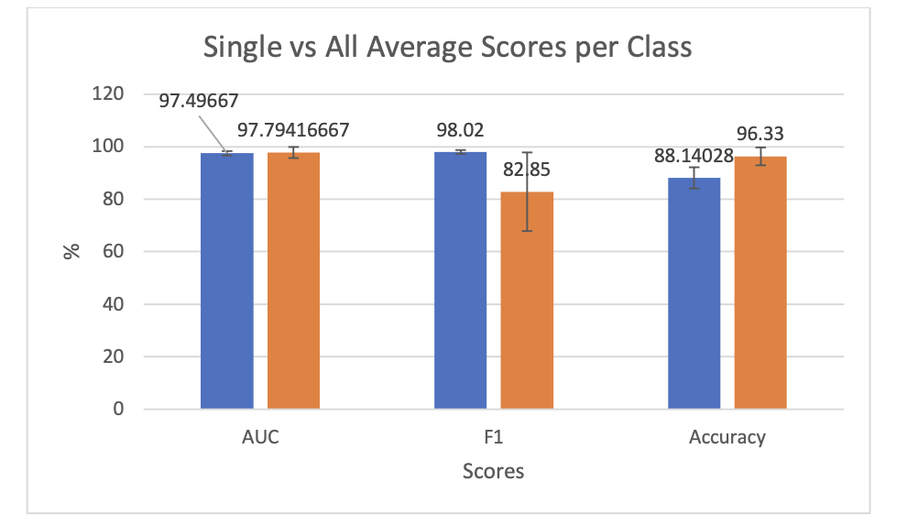

Figure ‎8‑2 – Classifier average results for single VS all average scores per movement (class)

The results obtained for the subject-specific model and the general model can be compared. The general model’s slightly lower Accuracy and F1score compared to the subject-specific model suggests that while the general model is robust, it remains more susceptible to the nuances of inter-subject differences. The AUC for the general model, which was higher for the second model, reflects strong discriminatory power but also highlights the challenges inherent in developing a model capable of generalizing effectively across different individuals. This issue is commonly encountered in EMG-based classification tasks, where models tailored to individual subjects frequently outperform those designed to generalize across multiple subjects due to the pronounced variability in the data.

The comparison of AUC, Accuracy and F1score between subject-specific and general models, as illustrated in Figure ‎8‑1 and Figure ‎8‑2, demonstrates the relative strengths and limitations of each approach. These figures highlight the importance of considering both individual variability and generalizability when designing EMG-based classification systems. These results can be attributed to the manual segmentation approach that utilizes precise and careful examination of each signal and returns highly accurate segments. Furthermore, the LDA technique that was employed before fitting the data into the classifiers improved the overall results by removing redundancies in the feature space and thus maintaining only the necessary features for an accurate classification.

The robust performance metrics obtained from both the subject-specific and general models have significant implications for real-world applications. For instance, in the development of prosthetic devices, the ability to accurately classify hand movements based on EMG signals is critical for creating intuitive and responsive control systems. The success of the subject-specific model suggests that personalized prosthetic systems, tailored to the unique EMG patterns of the individual user, could offer superior performance. Conversely, the general model’s robust performance across multiple subjects indicates the potential for developing more universal prosthetic control systems capable of adapting to a broader range of users. Similarly, in the context of rehabilitation, the accurate classification of hand movements can facilitate the monitoring of patient progress and the customization of therapeutic interventions to meet specific patient needs. The metrics obtained in this study demonstrate that both subject-specific and general models could be effectively applied in these contexts, with the choice of model depending on the specific requirements of the application.

## Comparison with literature data

The results obtained in this study were evaluated against findings from several key studies, notably Rabin et al. (2020) [1], Gómez Correa et al. (2023) [11], Raurale et al. (2021) [9], and Reaz et al. (2006) [7]. These comparisons are crucial for contextualizing the performance of the classification models developed for EMG-based hand movement recognition.

### Subject-Specific Models

The subject-specific model high precision rate of 91.9% demonstrates robust performance in classifying hand movements based on EMG signals. This result is comparable to the findings of Rabin et al. (2020) [1], where a PCA-based method yielded a similar accuracy of 94.8% when using a large portion of the dataset for training. Rabin et al, also explored non-linear dimensionality reduction techniques, such as Diffusion Maps (DM), which showed improved stability with smaller training sets. The use of Linear Discriminant Analysis (LDA) contrasts with Rabin et al.'s exploration of both PCA and DM, highlighting the potential of non-linear methods for maintaining classification accuracy with reduced training data.

In comparison, Raurale et al. (2021) [9] reported a high accuracy of over 92% in EMG-based biometric identification using a combination of amplitude normalization and multi-layer perceptron (MLP) classification. The similarity in accuracy between our study and that of Raurale et al. suggests that both approaches effectively captured the intricate patterns within EMG signals, despite differences in methodologies and application focuses.

### General Models

The general model developed in our study achieved an accuracy of 88.3%, which is significant when compared to the multi-subject classification accuracy reported by Rabin et al. (2020) [1]. In their work, the DM method combined with an alignment algorithm produced an average success rate of 76.4% for multi-subject classification, demonstrating the effectiveness of our model in handling data from multiple subjects.

Similarly, the study by Gómez Correa et al. (2023) [11] supports the high performance of our general model. They applied artificial neural networks (ANNs) to classify hand movements from EMG data, achieving high classification accuracy. Although Gómez Correa et al. focused on a different set of movements and used a more extensive dataset, the flexibility of our model to handle a variety of movements with fewer subjects suggests that it could be adapted and expanded to achieve similar or superior results.

The robustness of our general model, despite the variability introduced by inter-subject differences, also aligns with the findings of Reaz et al. (2006) [7], which had a success rate of 89.33%. Their work emphasized the importance of advanced signal processing techniques, such as wavelet spectrum matching and PCA, for improving classification accuracy in complex EMG datasets. The comparable performance underscores the effectiveness of our feature extraction and classification strategies, even in the face of significant data variability.

## Error Assessment and Project Limitations

Despite the strong performance observed in the study, several limitations were identified. Significant inter-subject variability was noted, as there was considerable variance in EMG signals between different subjects. This variability impacted the performance of the general model, which had to account for the differences between subjects. In contrast, the subject-specific model benefited from the consistency of data from a single individual.

Movement complexity also presented a limitation. Certain movements, such as Pinch Grip, were not well-represented in the data and were subsequently excluded from the analysis. This indicated that more complex movements may have required additional data or different segmentation techniques to be accurately classified.

Additionally, the size of the dataset, although considered adequate for the purposes of this study, could be seen as a limiting factor. It was recognized that increasing the number of subjects and repetitions would likely have enhanced the robustness and generalization of the models. A larger dataset would have provided more training examples, potentially leading to improved classification accuracy.

## Suggestions for Future Work

To further improve the performance and applicability of the models developed in this study, several future work directions can be proposed. One suggestion is the inclusion of a third model designed to test individuals not included in the original database, with the goal of recognizing their hand movements based on the nine movements studied. Preliminary tests showed a significant drop in success rates, likely due to the high variance between subjects. To address this issue, alignment techniques, such as dynamic time warping (DTW) or other alignment algorithms, could be implemented to standardize EMG signal patterns across different individuals, potentially improving the model's performance.

Another proposed direction is the expansion of the dataset by including more subjects and repetitions. This expansion would enhance the robustness and accuracy of the general model. A larger dataset would provide a more diverse set of training examples, improving the model's ability to generalize to new subjects. Additionally, incorporating other hand movements into the dataset could broaden the model’s applicability.

Exploration of advanced segmentation methods can also be suggested. By investigating semi-automated or machine learning-based segmentation, the accuracy of manual segmentation could be combined with the efficiency of automated processes. This approach would ensure precise segmentation while reducing the time and effort required.

Finally, the implementation of alignment techniques could reduce variability between subjects, which could improve the third model's performance. Techniques such as dynamic time warping (DTW) or other alignment algorithms could be explored to standardize EMG signal patterns across different individuals, thereby enhancing the model's ability to generalize to new subjects.

These steps could lead to further improvements in the recognition accuracy of hand movements based on EMG signals and expand the applicability of the developed models to real-world scenarios. By addressing the identified limitations and exploring new techniques, future work could build on the strong foundation established in this study, advancing the field of EMG-based hand movement classification.

# Conclusions

In this project, classification models were developed and evaluated to recognize hand movements based on EMG signals, using both subject-specific and general models. A precision of 91.9% was achieved for the subject-specific model, while the general model reached 88.3%. These high-performance metrics were attributed to the manual segmentation of the EMG data, effective feature extraction using STFT, and robust classification through a voting ensemble of SVM, RF and KNN. Comparisons with existing studies demonstrated that this approach is competitive, particularly due to the precision of manual segmentation and the strategic use of multiple classifiers. Despite limitations such as inter-subject variability and movement complexity, the results were promising. Future work should focus on expanding the dataset, exploring advanced segmentation methods, and implementing alignment techniques to further enhance model performance and applicability. A solid foundation is provided by this study for EMG-based hand movement classification, highlighting areas for continued research and development.

# References

|  |  |
| --- | --- |
| [1] | H. Gray, "1F. The Muscles and Fasciæ of the Hand," 1918. [Online]. Available: https://www.bartleby.com/lit-hub/anatomy-of-the-human-body/1f-the-muscles-and-fasci-of-the-hand/. |
| [2] | S. Panchal-Kildare and K. Malone, "Skeletal Anatomy of the Hand," *Management of Hand Fractures,* vol. 29, no. 4, pp. 459-471, 2013. |
| [3] | A. Rad, "Hand Anatomy: Bones, muscles, arteries and nerves," 2023. [Online]. Available: https://www.kenhub.com/en/library/anatomy/hand-anatomy. |
| [4] | N. Rabin, M. Kahlon, S. Malayev and A. Ratnovsky, "Classification of human hand movements based on EMG signals using nonlinear dimensionality reduction and data fusion techniques," *Expert Systems with Applications,* vol. 149, no. Article 113281, 2020. |
| [5] | C. Li, G. Li, G. Jiang, D. Chen and H. Liu, "Surface EMG data aggregation processing for intelligent prosthetic action recognition," *Neural Computing and Applications,* vol. 32, p. 16795–16806, 2020. |
| [6] | N. Parajuli, N. Sreenivasan, P. Bifulco, M. Cesarelli, S. Savino and V. Niola, "Real-Time EMG Based Pattern Recognition Control for Hand Prostheses: A Review on Existing Methods, Challenges and Future Implementation," *Sensors,* vol. 19, no. 20, p. 4596, 2019. |
| [7] | M. B. I. Reaz, M. S. Hussain and F. Mohd-Yasin, "Techniques of EMG signal analysis: detection, processing, classification and applications," *Biological Procedures Online,* vol. 8, pp. 11-35, 2006. |
| [8] | Y. Sun, C. Xu, G. Li, W. Xu, J. Kong, B. Tao and D. Chen, "Intelligent human computer interaction based on non redundant EMG signal.," *Alexandria Engineering Journal,* vol. 59, no. 3, pp. 1140-1157, 2020. |
| [9] | S. Raurale, J. McAllister and J. Rincón, "EMG Biometric Systems Based on Different Wrist-Hand Movements," *IEEE Access,* vol. 9, pp. 12256-12266, 2021. |
| [10] | J. Qi, G. Jiang, G. Li, Y. Sun and B. Tao, "Surface EMG hand gesture recognition system based on PCA and GRNN. Neural Computing and Applications," *Neural Computing and Applications,* vol. 32, p. 6343–6351, 2020. |
| [11] | K. Zhu, W. Guo, G. Yang, Z. Li and H. Wu, "Supporting Information for - High-fidelity Recording of EMG Signals by Multichannel on-skin Electrode Arrays from Target Muscles for Effective Human-machine Interfaces," Wuhan, 2021. |
| [12] | M. Gomez-Correa, M. Ballesteros, I. Salgado and D. Cruz-Ortiz, "Forearm sEMG data from young healthy humans during the execution of hand movements," *Scientific data,* vol. 10, no. 310, 2023. |

# Appendices

## Work Plan

Table ‎11‑1 shows the future work stages of the project, divided into major parts and estimated deadlines.

Table ‎11‑1 – Work Plan

|  |  |  |  |
| --- | --- | --- | --- |
| **Stage** | **Description** | **Timeline** | **Comments** |
| Measurements | Data collection – gathering a list of subjects for EMG measurements, fixing a day (or a couple) for using the lab, making the measurements according to ‎6.1.1 | Summer semester and first few weeks of fall semester.  **COMPLETED** | Authorization from internal ethics committee is required and authorization to use the lab from Nir. |
| Data Processing | Pre-filtering and Feature extraction according to ‎6.2.1 and ‎0 | Through the fall semester.  **COMPLETED** |  |
| Dimensionality Reduction and Classification | Processing the feature extracted in the previous stage according to DR methods described in ‎5.5 and designing the algorithm for classification using the methods described in ‎5.6. | Few weeks into the spring semester.  **Deadline – Beginning of May 2024**  **COMPLETED** |  |
| Engineering report | Completing and submitting the engineering report. | **Deadline – 17.03.2024**  **COMPLETED** |  |
| Results analysis | Implementing different combinations and a statistical analysis of the results | **Deadline – Beginning of June 2024**  **COMPLETED** |  |
| Project book and poster | Writing in the results after analysis, writing down discussions and conclusions | **Deadline – Until project book is due, end of 4th year**  **COMPLETED** |  |

## Application form for conducting a non-medical experiment on humans

Table ‎11‑2 – Approval of the internal ethics committee of Afeka college of engineering

|  |  |  |
| --- | --- | --- |
| תאריך הגשת הבקשה: 23/08/2023 | | מספר הבקשה בוועדת האתיקה (למילוי ע"י מזכירות הוועדה): |
| החוקר הראשי לניסוי (שם ומחלקה) Dr Sara Naftali and Prof Anat Ratnovsky – Medical engineering | | |
| מספר הטלפון: **0507266049, 0542255490** | | מספר הפקס: |
| חוקרי משנה (שם ומחלקה): Niv Edvi and Emma Tordjman | | |
| נושא הניסוי:  **סיווג תנועות ידיים שונות באמצעות אותות** EMG **נרכשים** | | |
| פרוטוקול הניסוי – מספר: **1** | | תאריך הפרוטוקול: |
| טופס הסכמה– גרסה: **1** | | תאריך טופס ההסכמה: |
|  | | |
| מטרות הניסוי:  **מדידה של אותות** EMG **וסיווג תנועות ידיים** | | |
| שם יוזם המחקר וכתובתו:  Dr Sara Naftali and Prof Anat Ratnovsky | מספר הטלפון: **0507266049, 0542255490**  מספר הפקס: | |
| שם נציג היוזם בארץ וכתובתו: | מספר הטלפון:  מספר הפקס:  שם איש הקשר: | |
| לחוקר הראשי או לאחד מחוקרי המשנה יש / אין קשר של העסקה בשכר, או קשר מסחרי או עסקי, או קשר משפחתי או אישי, וכל קשר אחר, לרבות קשר של כפיפות בעבודה, שיש בו כדי לעורר חשש לקיום ניגוד עניינים או תלות, ולמעט החזר הוצאות ליוזם הניסוי.  אם יש, פרט. | | |
| החוקר הראשי הוא גם יוזם הניסוי  כן  לא | | |
| מתכונת הניסוי (לדוגמא: מחקר פתוח, השוואתי, מבוקר סמוי, מבוקר כפול סמיות, וכד')  אני מבקש מהועדה לקבוע כי המחקר האמור אינו מחקר רפואי בבני אדם וזאת מהטעמים הבאים: | | |

## Changes summary

Only few changes were required from the originally planned project: 3 muscles were used to record the movements instead of 4 (the Abductor Pollicis Longus wasn’t used), 9 hands movements were included and not 10 (the Pinch Grip movement wasn’t used) and the Short-Time Fourier Transform was used instead of the Wavelet Transform.

## Python Codes

Various modules were created for the processing, segmentation, feature and classification stages, each one was imported into the next, and in addition, a library called “Pickle” was used to copy variables after each processing step into the next without having to run the entire code again.

The modules are:

* function_for_project.py – Module containing all functions for the project
* Person.py – Code defining the data structure of class “Person”
* persons.py – Subjects initialization, Extraction of BIOPAC data into “Person” class objects
* segmentation_prep.py – Transformation of signals to MATLAB files
* signal_segmentation.m – Acquisition of segments time stamps for data segmentation
* segmentation.py – Data segmentation
* feature_extraction.py – Time and frequency feature extraction
* features.py – Feature extraction
* data_matrix_creation.py – Features data frames for each subject
* LDA.py – Dimensionality reduction
* model_voting.py – Classification models
* classification_new.py – Classification algorithm
* result_analysis.py – Functions for result analysis
* main.py – Cross validation and classification algorithm implementation

All aforementioned modules are provided inside the same zip folder.

## Project Poster

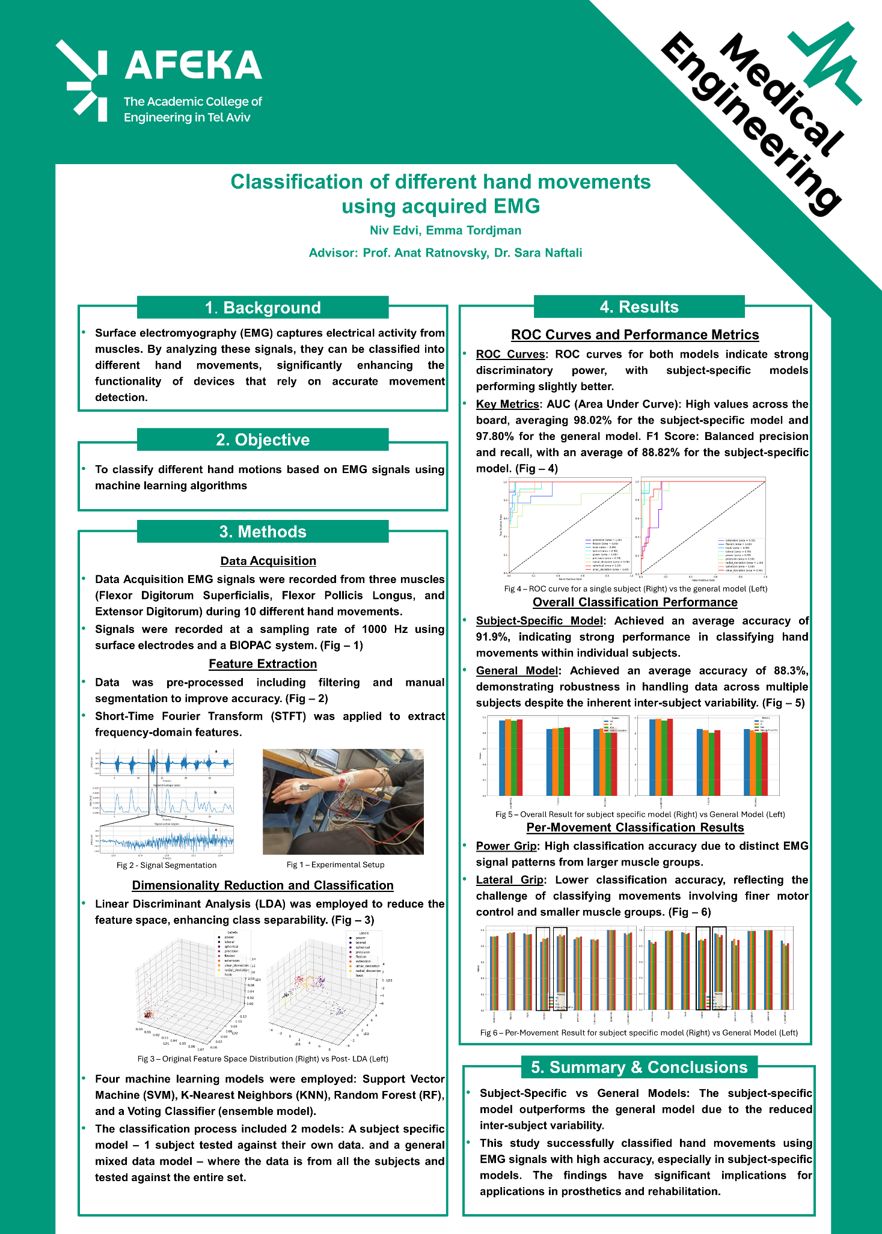

## Previous Study Article

